Preliminary ESP regressions

Abigail Tyrell

26 Apr 2021

# Black sea bass

Stock region: Mid

EPU: MAB, All, all, NE

# 1 Introduction

These are preliminary regressions that compare Mid Black sea bass catch, abundance, recruitment, and F to various indicators in the MAB, All, all, NE Environmental Protection Units (EPUs) taken from the ecodata package. The indicators are lagged by 1 years.

# 2 Regression analysis

All regressions are simple linear correlations assessed at the p < 0.5 level. Please note, due to the large number of indicators tested, a certain amount of statistically significant results are expected even if there are no underlying mechanistic connections. These correlations do not necessarily imply causation.

## 2.1 Trends with time

#### Figures

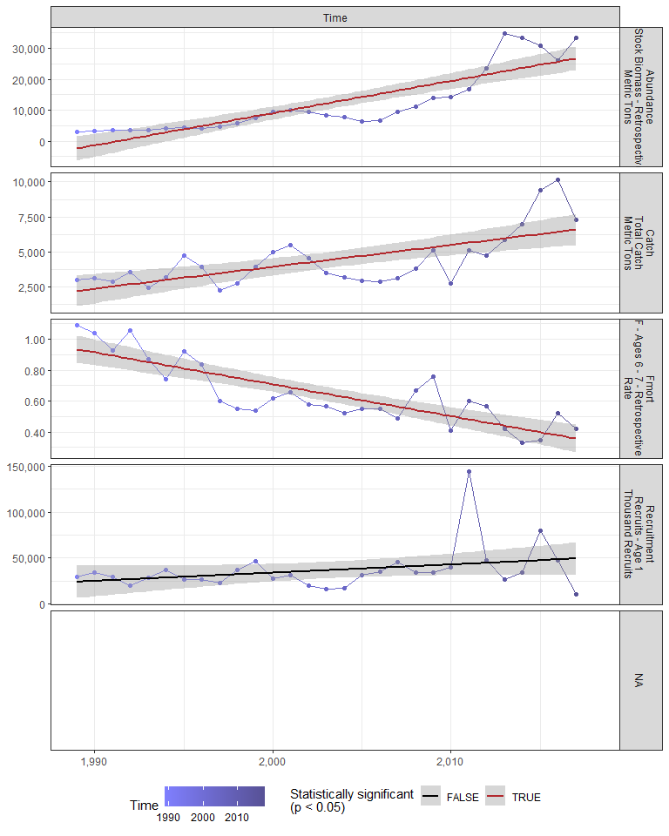

#### Regression statistics

Table 2.1: Catch vs Time

|  |  |  |  |  |
| --- | --- | --- | --- | --- |
|  | Estimate | Std. Error | t value | Pr(>|t|) |
| (Intercept) | -307118.84 | 66180.85 | -4.64 | 0 |
| Val | 155.53 | 33.04 | 4.71 | 0 |

|  |  |
| --- | --- |
| Name | Value |
| F-statistic | 22.16 |
| df | 1, 27 |
| R2 | 0.45 |
| R2-adj | 0.43 |

Table 2.1: Fmort vs Time

|  |  |  |  |  |
| --- | --- | --- | --- | --- |
|  | Estimate | Std. Error | t value | Pr(>|t|) |
| (Intercept) | 41.95 | 5.33 | 7.87 | 0 |
| Val | -0.02 | 0.00 | -7.75 | 0 |

|  |  |
| --- | --- |
| Name | Value |
| F-statistic | 60.1 |
| df | 1, 27 |
| R2 | 0.69 |
| R2-adj | 0.68 |

Table 2.1: Abundance vs Time

|  |  |  |  |  |
| --- | --- | --- | --- | --- |
|  | Estimate | Std. Error | t value | Pr(>|t|) |
| (Intercept) | -2070955 | 231857.79 | -8.93 | 0 |
| Val | 1040 | 115.75 | 8.98 | 0 |

|  |  |
| --- | --- |
| Name | Value |
| F-statistic | 80.72 |
| df | 1, 27 |
| R2 | 0.75 |
| R2-adj | 0.74 |

## 2.2 Physical indicators

### 2.2.1 Cold pool index

#### Figures

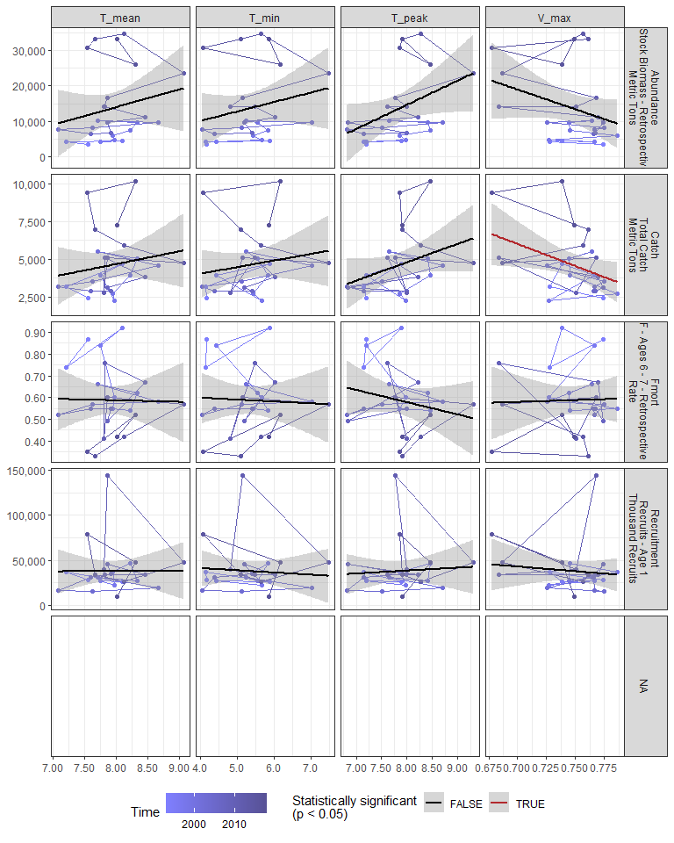

#### Regression statistics

Table 2.2: Catch vs V_max

|  |  |  |  |  |
| --- | --- | --- | --- | --- |
|  | Estimate | Std. Error | t value | Pr(>|t|) |
| (Intercept) | 26413.32 | 9926.97 | 2.66 | 0.01 |
| Val | -29157.48 | 13268.12 | -2.20 | 0.04 |

|  |  |
| --- | --- |
| Name | Value |
| F-statistic | 4.83 |
| df | 1, 23 |
| R2 | 0.17 |
| R2-adj | 0.14 |

### 2.2.2 Warm core rings

#### Figures

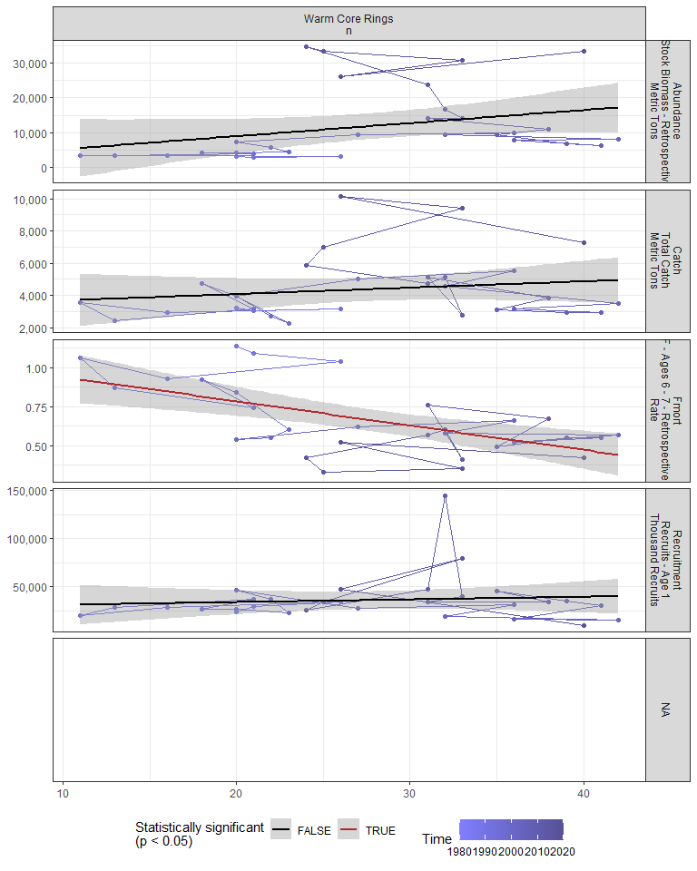

#### Regression statistics

Table 2.3: Fmort vs Warm Core Rings n

|  |  |  |  |  |
| --- | --- | --- | --- | --- |
|  | Estimate | Std. Error | t value | Pr(>|t|) |
| (Intercept) | 1.10 | 0.12 | 9.45 | 0 |
| Val | -0.02 | 0.00 | -3.90 | 0 |

|  |  |
| --- | --- |
| Name | Value |
| F-statistic | 15.19 |
| df | 1, 28 |
| R2 | 0.35 |
| R2-adj | 0.33 |

### 2.2.3 Marine heatwave index

#### Figures

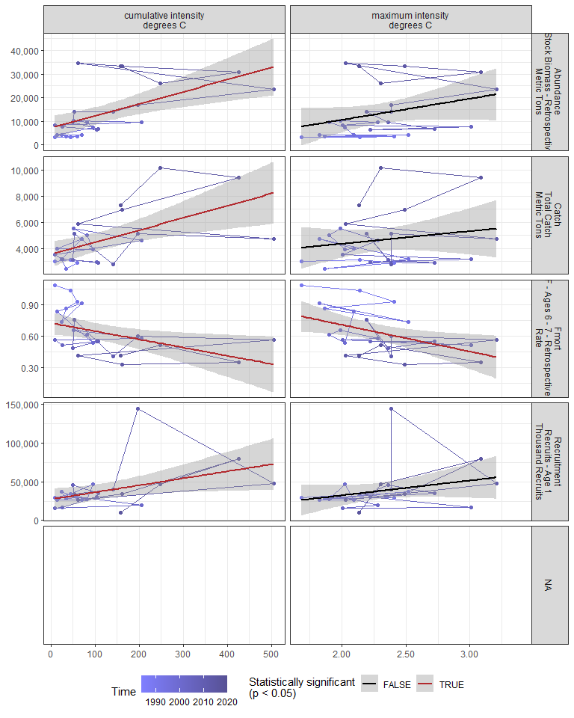

#### Regression statistics

Table 2.4: Catch vs cumulative intensity degrees C

|  |  |  |  |  |
| --- | --- | --- | --- | --- |
|  | Estimate | Std. Error | t value | Pr(>|t|) |
| (Intercept) | 3531.16 | 476.48 | 7.41 | 0 |
| Val | 9.30 | 2.82 | 3.30 | 0 |

|  |  |
| --- | --- |
| Name | Value |
| F-statistic | 10.89 |
| df | 1, 23 |
| R2 | 0.32 |
| R2-adj | 0.29 |

Table 2.4: Fmort vs cumulative intensity degrees C

|  |  |  |  |  |
| --- | --- | --- | --- | --- |
|  | Estimate | Std. Error | t value | Pr(>|t|) |
| (Intercept) | 0.73 | 0.05 | 13.69 | 0.00 |
| Val | 0.00 | 0.00 | -2.49 | 0.02 |

|  |  |
| --- | --- |
| Name | Value |
| F-statistic | 6.19 |
| df | 1, 23 |
| R2 | 0.21 |
| R2-adj | 0.18 |

Table 2.4: Fmort vs maximum intensity degrees C

|  |  |  |  |  |
| --- | --- | --- | --- | --- |
|  | Estimate | Std. Error | t value | Pr(>|t|) |
| (Intercept) | 1.22 | 0.23 | 5.29 | 0.00 |
| Val | -0.26 | 0.10 | -2.57 | 0.02 |

|  |  |
| --- | --- |
| Name | Value |
| F-statistic | 6.6 |
| df | 1, 23 |
| R2 | 0.22 |
| R2-adj | 0.19 |

Table 2.4: Recruitment vs cumulative intensity degrees C

|  |  |  |  |  |
| --- | --- | --- | --- | --- |
|  | Estimate | Std. Error | t value | Pr(>|t|) |
| (Intercept) | 27233.93 | 6711.26 | 4.06 | 0.00 |
| Val | 90.00 | 39.71 | 2.27 | 0.03 |

|  |  |
| --- | --- |
| Name | Value |
| F-statistic | 5.14 |
| df | 1, 23 |
| R2 | 0.18 |
| R2-adj | 0.15 |

Table 2.4: Abundance vs cumulative intensity degrees C

|  |  |  |  |  |
| --- | --- | --- | --- | --- |
|  | Estimate | Std. Error | t value | Pr(>|t|) |
| (Intercept) | 7099.18 | 2439.91 | 2.91 | 0.01 |
| Val | 51.19 | 14.44 | 3.55 | 0.00 |

|  |  |
| --- | --- |
| Name | Value |
| F-statistic | 12.58 |
| df | 1, 23 |
| R2 | 0.35 |
| R2-adj | 0.33 |

### 2.2.4 GLORYS bottom temperature

#### Figures

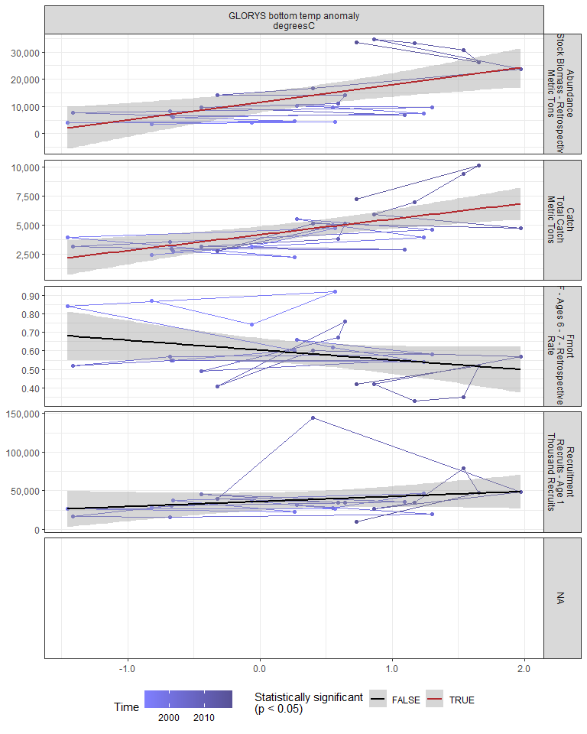

#### Regression statistics

Table 2.5: Catch vs GLORYS bottom temp anomaly degreesC

|  |  |  |  |  |
| --- | --- | --- | --- | --- |
|  | Estimate | Std. Error | t value | Pr(>|t|) |
| (Intercept) | 4161.68 | 348.97 | 11.93 | 0 |
| Val | 1359.11 | 355.03 | 3.83 | 0 |

|  |  |
| --- | --- |
| Name | Value |
| F-statistic | 14.65 |
| df | 1, 23 |
| R2 | 0.39 |
| R2-adj | 0.36 |

Table 2.5: Abundance vs GLORYS bottom temp anomaly degreesC

|  |  |  |  |  |
| --- | --- | --- | --- | --- |
|  | Estimate | Std. Error | t value | Pr(>|t|) |
| (Intercept) | 11455.96 | 1815.64 | 6.31 | 0 |
| Val | 6429.92 | 1847.18 | 3.48 | 0 |

|  |  |
| --- | --- |
| Name | Value |
| F-statistic | 12.12 |
| df | 1, 23 |
| R2 | 0.35 |
| R2-adj | 0.32 |

### 2.2.5 Long-term sea surface temperature

#### Figures

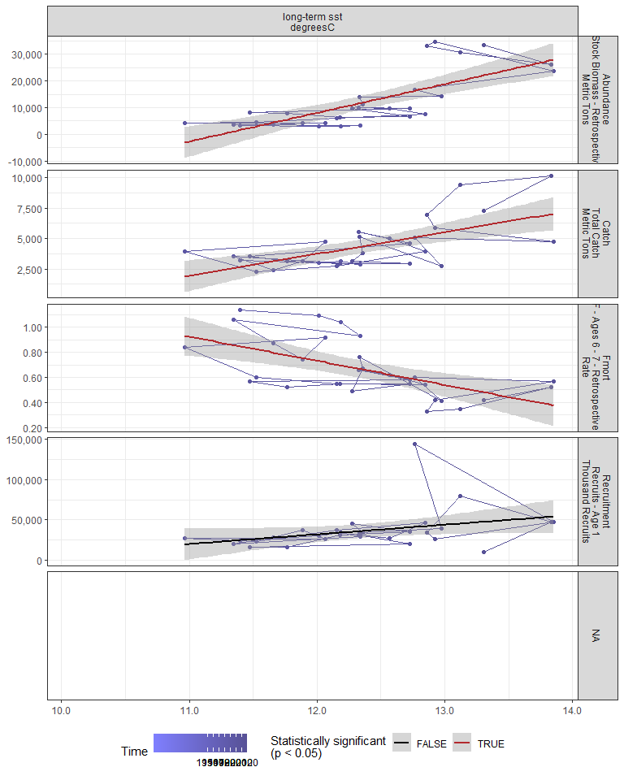

#### Regression statistics

Table 2.6: Catch vs long-term sst degreesC

|  |  |  |  |  |
| --- | --- | --- | --- | --- |
|  | Estimate | Std. Error | t value | Pr(>|t|) |
| (Intercept) | -17672.95 | 4983.39 | -3.55 | 0 |
| Val | 1784.02 | 402.62 | 4.43 | 0 |

|  |  |
| --- | --- |
| Name | Value |
| F-statistic | 19.63 |
| df | 1, 28 |
| R2 | 0.41 |
| R2-adj | 0.39 |

Table 2.6: Fmort vs long-term sst degreesC

|  |  |  |  |  |
| --- | --- | --- | --- | --- |
|  | Estimate | Std. Error | t value | Pr(>|t|) |
| (Intercept) | 3.04 | 0.61 | 5.02 | 0 |
| Val | -0.19 | 0.05 | -3.93 | 0 |

|  |  |
| --- | --- |
| Name | Value |
| F-statistic | 15.47 |
| df | 1, 28 |
| R2 | 0.36 |
| R2-adj | 0.33 |

Table 2.6: Abundance vs long-term sst degreesC

|  |  |  |  |  |
| --- | --- | --- | --- | --- |
|  | Estimate | Std. Error | t value | Pr(>|t|) |
| (Intercept) | -120713.25 | 22838.28 | -5.29 | 0 |
| Val | 10728.69 | 1845.17 | 5.81 | 0 |

|  |  |
| --- | --- |
| Name | Value |
| F-statistic | 33.81 |
| df | 1, 28 |
| R2 | 0.55 |
| R2-adj | 0.53 |

### 2.2.6 Sea surface temperature anomaly in EPU

#### Figures

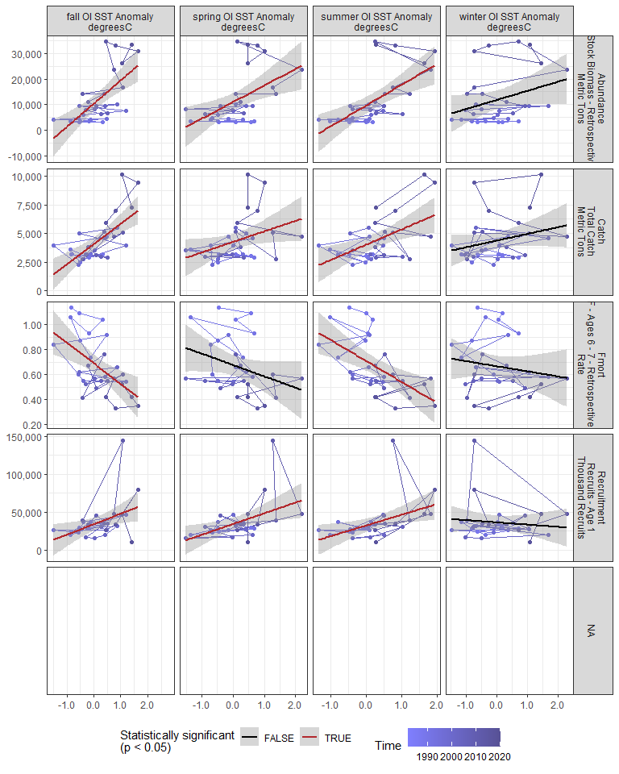

#### Regression statistics

Table 2.7: Catch vs fall OI SST Anomaly degreesC

|  |  |  |  |  |
| --- | --- | --- | --- | --- |
|  | Estimate | Std. Error | t value | Pr(>|t|) |
| (Intercept) | 4102.56 | 272.43 | 15.06 | 0 |
| Val | 1768.91 | 363.06 | 4.87 | 0 |

|  |  |
| --- | --- |
| Name | Value |
| F-statistic | 23.74 |
| df | 1, 28 |
| R2 | 0.46 |
| R2-adj | 0.44 |

Table 2.7: Catch vs spring OI SST Anomaly degreesC

|  |  |  |  |  |
| --- | --- | --- | --- | --- |
|  | Estimate | Std. Error | t value | Pr(>|t|) |
| (Intercept) | 4254.40 | 340.77 | 12.48 | 0.00 |
| Val | 921.04 | 431.08 | 2.14 | 0.04 |

|  |  |
| --- | --- |
| Name | Value |
| F-statistic | 4.57 |
| df | 1, 28 |
| R2 | 0.14 |
| R2-adj | 0.11 |

Table 2.7: Catch vs summer OI SST Anomaly degreesC

|  |  |  |  |  |
| --- | --- | --- | --- | --- |
|  | Estimate | Std. Error | t value | Pr(>|t|) |
| (Intercept) | 4024.02 | 327.25 | 12.30 | 0 |
| Val | 1335.11 | 411.21 | 3.25 | 0 |

|  |  |
| --- | --- |
| Name | Value |
| F-statistic | 10.54 |
| df | 1, 28 |
| R2 | 0.27 |
| R2-adj | 0.25 |

Table 2.7: Fmort vs fall OI SST Anomaly degreesC

|  |  |  |  |  |
| --- | --- | --- | --- | --- |
|  | Estimate | Std. Error | t value | Pr(>|t|) |
| (Intercept) | 0.69 | 0.04 | 19.17 | 0 |
| Val | -0.17 | 0.05 | -3.46 | 0 |

|  |  |
| --- | --- |
| Name | Value |
| F-statistic | 11.99 |
| df | 1, 28 |
| R2 | 0.3 |
| R2-adj | 0.27 |

Table 2.7: Fmort vs summer OI SST Anomaly degreesC

|  |  |  |  |  |
| --- | --- | --- | --- | --- |
|  | Estimate | Std. Error | t value | Pr(>|t|) |
| (Intercept) | 0.71 | 0.04 | 19.30 | 0 |
| Val | -0.17 | 0.05 | -3.65 | 0 |

|  |  |
| --- | --- |
| Name | Value |
| F-statistic | 13.31 |
| df | 1, 28 |
| R2 | 0.32 |
| R2-adj | 0.3 |

Table 2.7: Recruitment vs fall OI SST Anomaly degreesC

|  |  |  |  |  |
| --- | --- | --- | --- | --- |
|  | Estimate | Std. Error | t value | Pr(>|t|) |
| (Intercept) | 34016.90 | 4163.72 | 8.17 | 0.00 |
| Val | 13750.39 | 5548.74 | 2.48 | 0.02 |

|  |  |
| --- | --- |
| Name | Value |
| F-statistic | 6.14 |
| df | 1, 28 |
| R2 | 0.18 |
| R2-adj | 0.15 |

Table 2.7: Recruitment vs spring OI SST Anomaly degreesC

|  |  |  |  |  |
| --- | --- | --- | --- | --- |
|  | Estimate | Std. Error | t value | Pr(>|t|) |
| (Intercept) | 34286.32 | 4041.73 | 8.48 | 0.00 |
| Val | 14170.01 | 5112.84 | 2.77 | 0.01 |

|  |  |
| --- | --- |
| Name | Value |
| F-statistic | 7.68 |
| df | 1, 28 |
| R2 | 0.22 |
| R2-adj | 0.19 |

Table 2.7: Recruitment vs summer OI SST Anomaly degreesC

|  |  |  |  |  |
| --- | --- | --- | --- | --- |
|  | Estimate | Std. Error | t value | Pr(>|t|) |
| (Intercept) | 32436.50 | 4270.62 | 7.60 | 0.00 |
| Val | 14077.54 | 5366.41 | 2.62 | 0.01 |

|  |  |
| --- | --- |
| Name | Value |
| F-statistic | 6.88 |
| df | 1, 28 |
| R2 | 0.2 |
| R2-adj | 0.17 |

Table 2.7: Abundance vs fall OI SST Anomaly degreesC

|  |  |  |  |  |
| --- | --- | --- | --- | --- |
|  | Estimate | Std. Error | t value | Pr(>|t|) |
| (Intercept) | 10486.21 | 1447.99 | 7.24 | 0 |
| Val | 9033.07 | 1929.65 | 4.68 | 0 |

|  |  |
| --- | --- |
| Name | Value |
| F-statistic | 21.91 |
| df | 1, 28 |
| R2 | 0.44 |
| R2-adj | 0.42 |

Table 2.7: Abundance vs spring OI SST Anomaly degreesC

|  |  |  |  |  |
| --- | --- | --- | --- | --- |
|  | Estimate | Std. Error | t value | Pr(>|t|) |
| (Intercept) | 11031.30 | 1656.73 | 6.66 | 0 |
| Val | 6475.66 | 2095.78 | 3.09 | 0 |

|  |  |
| --- | --- |
| Name | Value |
| F-statistic | 9.55 |
| df | 1, 28 |
| R2 | 0.25 |
| R2-adj | 0.23 |

Table 2.7: Abundance vs summer OI SST Anomaly degreesC

|  |  |  |  |  |
| --- | --- | --- | --- | --- |
|  | Estimate | Std. Error | t value | Pr(>|t|) |
| (Intercept) | 9749.72 | 1591.95 | 6.12 | 0 |
| Val | 8097.17 | 2000.43 | 4.05 | 0 |

|  |  |
| --- | --- |
| Name | Value |
| F-statistic | 16.38 |
| df | 1, 28 |
| R2 | 0.37 |
| R2-adj | 0.35 |

### 2.2.7 Sea surface temperature anomaly in stock region

#### Figures

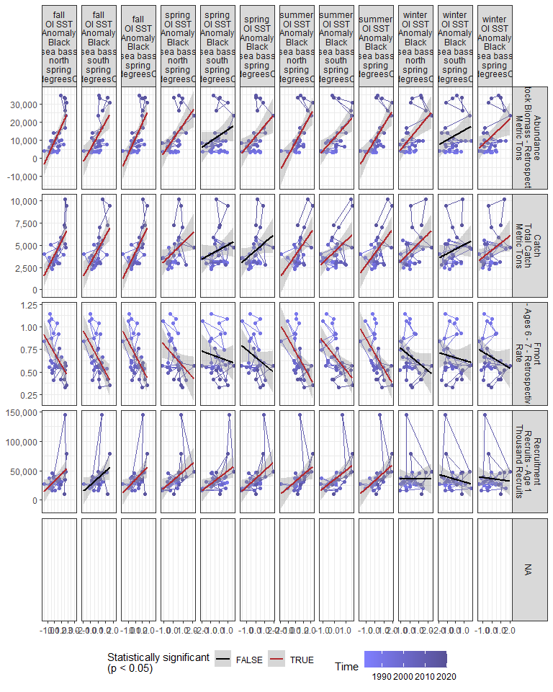

#### Regression statistics

Table 2.8: Catch vs fall OI SST Anomaly Black sea bass north spring degreesC

|  |  |  |  |  |
| --- | --- | --- | --- | --- |
|  | Estimate | Std. Error | t value | Pr(>|t|) |
| (Intercept) | 3878.66 | 278.87 | 13.91 | 0 |
| Val | 1478.44 | 290.61 | 5.09 | 0 |

|  |  |
| --- | --- |
| Name | Value |
| F-statistic | 25.88 |
| df | 1, 28 |
| R2 | 0.48 |
| R2-adj | 0.46 |

Table 2.8: Catch vs fall OI SST Anomaly Black sea bass south spring degreesC

|  |  |  |  |  |
| --- | --- | --- | --- | --- |
|  | Estimate | Std. Error | t value | Pr(>|t|) |
| (Intercept) | 4522.69 | 294.35 | 15.37 | 0 |
| Val | 1551.00 | 397.93 | 3.90 | 0 |

|  |  |
| --- | --- |
| Name | Value |
| F-statistic | 15.19 |
| df | 1, 28 |
| R2 | 0.35 |
| R2-adj | 0.33 |

Table 2.8: Catch vs fall OI SST Anomaly Black sea bass spring degreesC

|  |  |  |  |  |
| --- | --- | --- | --- | --- |
|  | Estimate | Std. Error | t value | Pr(>|t|) |
| (Intercept) | 4171.76 | 268.74 | 15.52 | 0 |
| Val | 1631.79 | 331.92 | 4.92 | 0 |

|  |  |
| --- | --- |
| Name | Value |
| F-statistic | 24.17 |
| df | 1, 28 |
| R2 | 0.46 |
| R2-adj | 0.44 |

Table 2.8: Catch vs spring OI SST Anomaly Black sea bass north spring degreesC

|  |  |  |  |  |
| --- | --- | --- | --- | --- |
|  | Estimate | Std. Error | t value | Pr(>|t|) |
| (Intercept) | 4193.23 | 344.62 | 12.17 | 0.00 |
| Val | 1077.95 | 489.61 | 2.20 | 0.04 |

|  |  |
| --- | --- |
| Name | Value |
| F-statistic | 4.85 |
| df | 1, 28 |
| R2 | 0.15 |
| R2-adj | 0.12 |

Table 2.8: Catch vs summer OI SST Anomaly Black sea bass north spring degreesC

|  |  |  |  |  |
| --- | --- | --- | --- | --- |
|  | Estimate | Std. Error | t value | Pr(>|t|) |
| (Intercept) | 3910.94 | 341.86 | 11.44 | 0 |
| Val | 1222.94 | 380.95 | 3.21 | 0 |

|  |  |
| --- | --- |
| Name | Value |
| F-statistic | 10.31 |
| df | 1, 28 |
| R2 | 0.27 |
| R2-adj | 0.24 |

Table 2.8: Catch vs summer OI SST Anomaly Black sea bass south spring degreesC

|  |  |  |  |  |
| --- | --- | --- | --- | --- |
|  | Estimate | Std. Error | t value | Pr(>|t|) |
| (Intercept) | 4248.50 | 326.81 | 13.00 | 0.00 |
| Val | 1223.85 | 456.96 | 2.68 | 0.01 |

|  |  |
| --- | --- |
| Name | Value |
| F-statistic | 7.17 |
| df | 1, 28 |
| R2 | 0.2 |
| R2-adj | 0.18 |

Table 2.8: Catch vs summer OI SST Anomaly Black sea bass spring degreesC

|  |  |  |  |  |
| --- | --- | --- | --- | --- |
|  | Estimate | Std. Error | t value | Pr(>|t|) |
| (Intercept) | 4082.91 | 324.21 | 12.59 | 0 |
| Val | 1336.58 | 421.48 | 3.17 | 0 |

|  |  |
| --- | --- |
| Name | Value |
| F-statistic | 10.06 |
| df | 1, 28 |
| R2 | 0.26 |
| R2-adj | 0.24 |

Table 2.8: Catch vs winter OI SST Anomaly Black sea bass north spring degreesC

|  |  |  |  |  |
| --- | --- | --- | --- | --- |
|  | Estimate | Std. Error | t value | Pr(>|t|) |
| (Intercept) | 4220.93 | 329.30 | 12.82 | 0.00 |
| Val | 996.60 | 376.37 | 2.65 | 0.01 |

|  |  |
| --- | --- |
| Name | Value |
| F-statistic | 7.01 |
| df | 1, 28 |
| R2 | 0.2 |
| R2-adj | 0.17 |

Table 2.8: Catch vs winter OI SST Anomaly Black sea bass spring degreesC

|  |  |  |  |  |
| --- | --- | --- | --- | --- |
|  | Estimate | Std. Error | t value | Pr(>|t|) |
| (Intercept) | 4432.93 | 338.07 | 13.11 | 0.00 |
| Val | 814.37 | 387.52 | 2.10 | 0.04 |

|  |  |
| --- | --- |
| Name | Value |
| F-statistic | 4.42 |
| df | 1, 28 |
| R2 | 0.14 |
| R2-adj | 0.11 |

Table 2.8: Fmort vs fall OI SST Anomaly Black sea bass north spring degreesC

|  |  |  |  |  |
| --- | --- | --- | --- | --- |
|  | Estimate | Std. Error | t value | Pr(>|t|) |
| (Intercept) | 0.71 | 0.04 | 18.41 | 0 |
| Val | -0.13 | 0.04 | -3.21 | 0 |

|  |  |
| --- | --- |
| Name | Value |
| F-statistic | 10.29 |
| df | 1, 28 |
| R2 | 0.27 |
| R2-adj | 0.24 |

Table 2.8: Fmort vs fall OI SST Anomaly Black sea bass south spring degreesC

|  |  |  |  |  |
| --- | --- | --- | --- | --- |
|  | Estimate | Std. Error | t value | Pr(>|t|) |
| (Intercept) | 0.65 | 0.04 | 17.88 | 0 |
| Val | -0.16 | 0.05 | -3.21 | 0 |

|  |  |
| --- | --- |
| Name | Value |
| F-statistic | 10.28 |
| df | 1, 28 |
| R2 | 0.27 |
| R2-adj | 0.24 |

Table 2.8: Fmort vs fall OI SST Anomaly Black sea bass spring degreesC

|  |  |  |  |  |
| --- | --- | --- | --- | --- |
|  | Estimate | Std. Error | t value | Pr(>|t|) |
| (Intercept) | 0.68 | 0.04 | 19.01 | 0 |
| Val | -0.15 | 0.04 | -3.37 | 0 |

|  |  |
| --- | --- |
| Name | Value |
| F-statistic | 11.38 |
| df | 1, 28 |
| R2 | 0.29 |
| R2-adj | 0.26 |

Table 2.8: Fmort vs spring OI SST Anomaly Black sea bass north spring degreesC

|  |  |  |  |  |
| --- | --- | --- | --- | --- |
|  | Estimate | Std. Error | t value | Pr(>|t|) |
| (Intercept) | 0.68 | 0.04 | 17.03 | 0.00 |
| Val | -0.12 | 0.06 | -2.13 | 0.04 |

|  |  |
| --- | --- |
| Name | Value |
| F-statistic | 4.54 |
| df | 1, 28 |
| R2 | 0.14 |
| R2-adj | 0.11 |

Table 2.8: Fmort vs summer OI SST Anomaly Black sea bass north spring degreesC

|  |  |  |  |  |
| --- | --- | --- | --- | --- |
|  | Estimate | Std. Error | t value | Pr(>|t|) |
| (Intercept) | 0.72 | 0.04 | 18.45 | 0 |
| Val | -0.15 | 0.04 | -3.40 | 0 |

|  |  |
| --- | --- |
| Name | Value |
| F-statistic | 11.58 |
| df | 1, 28 |
| R2 | 0.29 |
| R2-adj | 0.27 |

Table 2.8: Fmort vs summer OI SST Anomaly Black sea bass south spring degreesC

|  |  |  |  |  |
| --- | --- | --- | --- | --- |
|  | Estimate | Std. Error | t value | Pr(>|t|) |
| (Intercept) | 0.68 | 0.04 | 18.62 | 0 |
| Val | -0.16 | 0.05 | -3.14 | 0 |

|  |  |
| --- | --- |
| Name | Value |
| F-statistic | 9.89 |
| df | 1, 28 |
| R2 | 0.26 |
| R2-adj | 0.23 |

Table 2.8: Fmort vs summer OI SST Anomaly Black sea bass spring degreesC

|  |  |  |  |  |
| --- | --- | --- | --- | --- |
|  | Estimate | Std. Error | t value | Pr(>|t|) |
| (Intercept) | 0.70 | 0.04 | 19.14 | 0 |
| Val | -0.17 | 0.05 | -3.50 | 0 |

|  |  |
| --- | --- |
| Name | Value |
| F-statistic | 12.27 |
| df | 1, 28 |
| R2 | 0.3 |
| R2-adj | 0.28 |

Table 2.8: Recruitment vs fall OI SST Anomaly Black sea bass north spring degreesC

|  |  |  |  |  |
| --- | --- | --- | --- | --- |
|  | Estimate | Std. Error | t value | Pr(>|t|) |
| (Intercept) | 32349.11 | 4345.78 | 7.44 | 0.00 |
| Val | 11275.53 | 4528.66 | 2.49 | 0.02 |

|  |  |
| --- | --- |
| Name | Value |
| F-statistic | 6.2 |
| df | 1, 28 |
| R2 | 0.18 |
| R2-adj | 0.15 |

Table 2.8: Recruitment vs fall OI SST Anomaly Black sea bass spring degreesC

|  |  |  |  |  |
| --- | --- | --- | --- | --- |
|  | Estimate | Std. Error | t value | Pr(>|t|) |
| (Intercept) | 34594.19 | 4142.49 | 8.35 | 0.00 |
| Val | 12366.61 | 5116.36 | 2.42 | 0.02 |

|  |  |
| --- | --- |
| Name | Value |
| F-statistic | 5.84 |
| df | 1, 28 |
| R2 | 0.17 |
| R2-adj | 0.14 |

Table 2.8: Recruitment vs spring OI SST Anomaly Black sea bass north spring degreesC

|  |  |  |  |  |
| --- | --- | --- | --- | --- |
|  | Estimate | Std. Error | t value | Pr(>|t|) |
| (Intercept) | 33797.03 | 4249.69 | 7.95 | 0.00 |
| Val | 13891.34 | 6037.64 | 2.30 | 0.03 |

|  |  |
| --- | --- |
| Name | Value |
| F-statistic | 5.29 |
| df | 1, 28 |
| R2 | 0.16 |
| R2-adj | 0.13 |

Table 2.8: Recruitment vs summer OI SST Anomaly Black sea bass north spring degreesC

|  |  |  |  |  |
| --- | --- | --- | --- | --- |
|  | Estimate | Std. Error | t value | Pr(>|t|) |
| (Intercept) | 32034.91 | 4613.49 | 6.94 | 0.00 |
| Val | 10806.71 | 5141.06 | 2.10 | 0.04 |

|  |  |
| --- | --- |
| Name | Value |
| F-statistic | 4.42 |
| df | 1, 28 |
| R2 | 0.14 |
| R2-adj | 0.11 |

Table 2.8: Recruitment vs summer OI SST Anomaly Black sea bass south spring degreesC

|  |  |  |  |  |
| --- | --- | --- | --- | --- |
|  | Estimate | Std. Error | t value | Pr(>|t|) |
| (Intercept) | 34549.71 | 4044.79 | 8.54 | 0.00 |
| Val | 15377.46 | 5655.54 | 2.72 | 0.01 |

|  |  |
| --- | --- |
| Name | Value |
| F-statistic | 7.39 |
| df | 1, 28 |
| R2 | 0.21 |
| R2-adj | 0.18 |

Table 2.8: Recruitment vs summer OI SST Anomaly Black sea bass spring degreesC

|  |  |  |  |  |
| --- | --- | --- | --- | --- |
|  | Estimate | Std. Error | t value | Pr(>|t|) |
| (Intercept) | 33172.41 | 4258.14 | 7.79 | 0.00 |
| Val | 13565.26 | 5535.65 | 2.45 | 0.02 |

|  |  |
| --- | --- |
| Name | Value |
| F-statistic | 6.01 |
| df | 1, 28 |
| R2 | 0.18 |
| R2-adj | 0.15 |

Table 2.8: Recruitment vs spring OI SST Anomaly Black sea bass south spring degreesC

|  |  |  |  |  |
| --- | --- | --- | --- | --- |
|  | Estimate | Std. Error | t value | Pr(>|t|) |
| (Intercept) | 37887.22 | 4154.16 | 9.12 | 0.00 |
| Val | 11087.06 | 4566.36 | 2.43 | 0.02 |

|  |  |
| --- | --- |
| Name | Value |
| F-statistic | 5.9 |
| df | 1, 28 |
| R2 | 0.17 |
| R2-adj | 0.14 |

Table 2.8: Recruitment vs spring OI SST Anomaly Black sea bass spring degreesC

|  |  |  |  |  |
| --- | --- | --- | --- | --- |
|  | Estimate | Std. Error | t value | Pr(>|t|) |
| (Intercept) | 36426.60 | 4056.56 | 8.98 | 0.00 |
| Val | 14241.22 | 5589.02 | 2.55 | 0.02 |

|  |  |
| --- | --- |
| Name | Value |
| F-statistic | 6.49 |
| df | 1, 28 |
| R2 | 0.19 |
| R2-adj | 0.16 |

Table 2.8: Abundance vs fall OI SST Anomaly Black sea bass north spring degreesC

|  |  |  |  |  |
| --- | --- | --- | --- | --- |
|  | Estimate | Std. Error | t value | Pr(>|t|) |
| (Intercept) | 9171.39 | 1393.28 | 6.58 | 0 |
| Val | 8061.41 | 1451.92 | 5.55 | 0 |

|  |  |
| --- | --- |
| Name | Value |
| F-statistic | 30.83 |
| df | 1, 28 |
| R2 | 0.52 |
| R2-adj | 0.51 |

Table 2.8: Abundance vs fall OI SST Anomaly Black sea bass south spring degreesC

|  |  |  |  |  |
| --- | --- | --- | --- | --- |
|  | Estimate | Std. Error | t value | Pr(>|t|) |
| (Intercept) | 12592.69 | 1593.45 | 7.90 | 0 |
| Val | 7513.83 | 2154.17 | 3.49 | 0 |

|  |  |
| --- | --- |
| Name | Value |
| F-statistic | 12.17 |
| df | 1, 28 |
| R2 | 0.3 |
| R2-adj | 0.28 |

Table 2.8: Abundance vs fall OI SST Anomaly Black sea bass spring degreesC

|  |  |  |  |  |
| --- | --- | --- | --- | --- |
|  | Estimate | Std. Error | t value | Pr(>|t|) |
| (Intercept) | 10810.60 | 1396.10 | 7.74 | 0 |
| Val | 8566.44 | 1724.32 | 4.97 | 0 |

|  |  |
| --- | --- |
| Name | Value |
| F-statistic | 24.68 |
| df | 1, 28 |
| R2 | 0.47 |
| R2-adj | 0.45 |

Table 2.8: Abundance vs spring OI SST Anomaly Black sea bass north spring degreesC

|  |  |  |  |  |
| --- | --- | --- | --- | --- |
|  | Estimate | Std. Error | t value | Pr(>|t|) |
| (Intercept) | 10569.59 | 1652.06 | 6.40 | 0 |
| Val | 7767.60 | 2347.13 | 3.31 | 0 |

|  |  |
| --- | --- |
| Name | Value |
| F-statistic | 10.95 |
| df | 1, 28 |
| R2 | 0.28 |
| R2-adj | 0.26 |

Table 2.8: Abundance vs summer OI SST Anomaly Black sea bass north spring degreesC

|  |  |  |  |  |
| --- | --- | --- | --- | --- |
|  | Estimate | Std. Error | t value | Pr(>|t|) |
| (Intercept) | 9007.10 | 1646.33 | 5.47 | 0 |
| Val | 7566.88 | 1834.59 | 4.12 | 0 |

|  |  |
| --- | --- |
| Name | Value |
| F-statistic | 17.01 |
| df | 1, 28 |
| R2 | 0.38 |
| R2-adj | 0.36 |

Table 2.8: Abundance vs summer OI SST Anomaly Black sea bass south spring degreesC

|  |  |  |  |  |
| --- | --- | --- | --- | --- |
|  | Estimate | Std. Error | t value | Pr(>|t|) |
| (Intercept) | 11143.13 | 1653.12 | 6.74 | 0 |
| Val | 7110.62 | 2311.45 | 3.08 | 0 |

|  |  |
| --- | --- |
| Name | Value |
| F-statistic | 9.46 |
| df | 1, 28 |
| R2 | 0.25 |
| R2-adj | 0.23 |

Table 2.8: Abundance vs summer OI SST Anomaly Black sea bass spring degreesC

|  |  |  |  |  |
| --- | --- | --- | --- | --- |
|  | Estimate | Std. Error | t value | Pr(>|t|) |
| (Intercept) | 10109.86 | 1584.16 | 6.38 | 0 |
| Val | 8092.40 | 2059.44 | 3.93 | 0 |

|  |  |
| --- | --- |
| Name | Value |
| F-statistic | 15.44 |
| df | 1, 28 |
| R2 | 0.36 |
| R2-adj | 0.33 |

Table 2.8: Abundance vs winter OI SST Anomaly Black sea bass north spring degreesC

|  |  |  |  |  |
| --- | --- | --- | --- | --- |
|  | Estimate | Std. Error | t value | Pr(>|t|) |
| (Intercept) | 10946.14 | 1643.54 | 6.66 | 0 |
| Val | 6029.63 | 1878.48 | 3.21 | 0 |

|  |  |
| --- | --- |
| Name | Value |
| F-statistic | 10.3 |
| df | 1, 28 |
| R2 | 0.27 |
| R2-adj | 0.24 |

Table 2.8: Abundance vs winter OI SST Anomaly Black sea bass spring degreesC

|  |  |  |  |  |
| --- | --- | --- | --- | --- |
|  | Estimate | Std. Error | t value | Pr(>|t|) |
| (Intercept) | 12214.97 | 1731.01 | 7.06 | 0.00 |
| Val | 4735.67 | 1984.22 | 2.39 | 0.02 |

|  |  |
| --- | --- |
| Name | Value |
| F-statistic | 5.7 |
| df | 1, 28 |
| R2 | 0.17 |
| R2-adj | 0.14 |

Table 2.8: Abundance vs spring OI SST Anomaly Black sea bass spring degreesC

|  |  |  |  |  |
| --- | --- | --- | --- | --- |
|  | Estimate | Std. Error | t value | Pr(>|t|) |
| (Intercept) | 11999.68 | 1701.92 | 7.05 | 0.00 |
| Val | 6045.67 | 2344.87 | 2.58 | 0.02 |

|  |  |
| --- | --- |
| Name | Value |
| F-statistic | 6.65 |
| df | 1, 28 |
| R2 | 0.19 |
| R2-adj | 0.16 |

### 2.2.8 Stratification

#### Figures

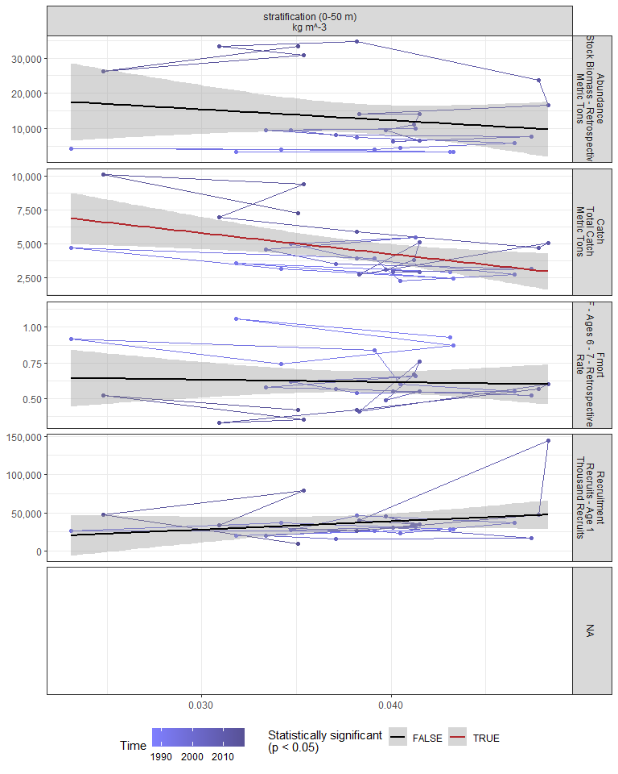

#### Regression statistics

Table 2.9: Catch vs stratification (0-50 m) kg m^-3

|  |  |  |  |  |
| --- | --- | --- | --- | --- |
|  | Estimate | Std. Error | t value | Pr(>|t|) |
| (Intercept) | 10497.99 | 2181.53 | 4.81 | 0.00 |
| Val | -155908.94 | 56111.74 | -2.78 | 0.01 |

|  |  |
| --- | --- |
| Name | Value |
| F-statistic | 7.72 |
| df | 1, 25 |
| R2 | 0.24 |
| R2-adj | 0.21 |

### 2.2.9 Winter wind speed

#### Figures

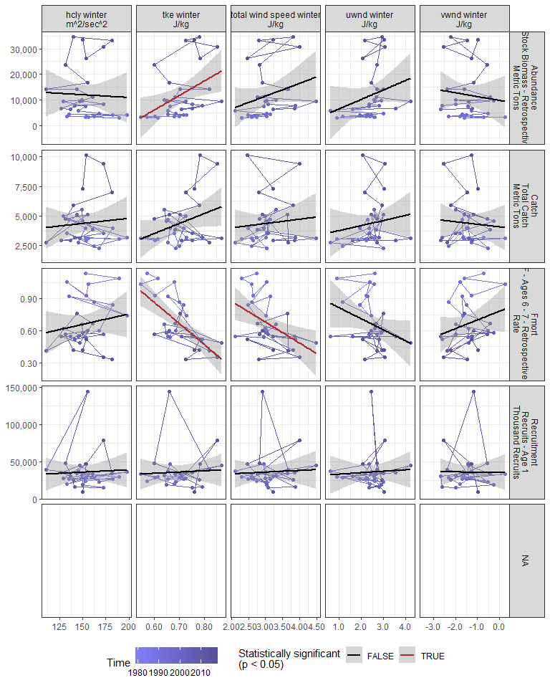

#### Regression statistics

Table 2.10: Fmort vs tke winter J/kg

|  |  |  |  |  |
| --- | --- | --- | --- | --- |
|  | Estimate | Std. Error | t value | Pr(>|t|) |
| (Intercept) | 2.06 | 0.28 | 7.41 | 0 |
| Val | -1.98 | 0.39 | -5.05 | 0 |

|  |  |
| --- | --- |
| Name | Value |
| F-statistic | 25.46 |
| df | 1, 28 |
| R2 | 0.48 |
| R2-adj | 0.46 |

Table 2.10: Fmort vs total wind speed winter J/kg

|  |  |  |  |  |
| --- | --- | --- | --- | --- |
|  | Estimate | Std. Error | t value | Pr(>|t|) |
| (Intercept) | 1.27 | 0.21 | 5.93 | 0.00 |
| Val | -0.20 | 0.07 | -2.87 | 0.01 |

|  |  |
| --- | --- |
| Name | Value |
| F-statistic | 8.23 |
| df | 1, 28 |
| R2 | 0.23 |
| R2-adj | 0.2 |

Table 2.10: Abundance vs tke winter J/kg

|  |  |  |  |  |
| --- | --- | --- | --- | --- |
|  | Estimate | Std. Error | t value | Pr(>|t|) |
| (Intercept) | -28194.90 | 15487.66 | -1.82 | 0.08 |
| Val | 56959.11 | 21884.15 | 2.60 | 0.01 |

|  |  |
| --- | --- |
| Name | Value |
| F-statistic | 6.77 |
| df | 1, 28 |
| R2 | 0.19 |
| R2-adj | 0.17 |

### 2.2.10 Spring wind speed

#### Figures

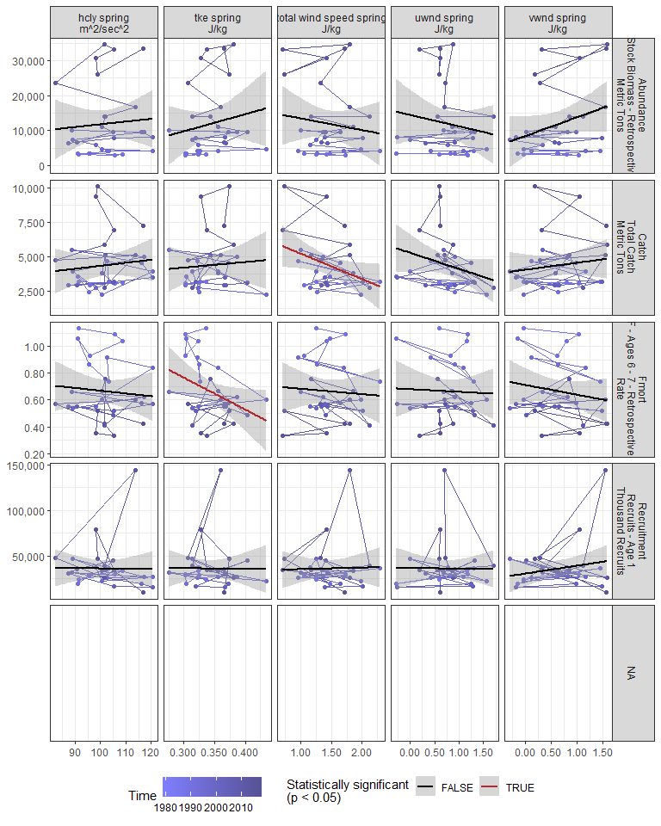

#### Regression statistics

Table 2.11: Catch vs total wind speed spring J/kg

|  |  |  |  |  |
| --- | --- | --- | --- | --- |
|  | Estimate | Std. Error | t value | Pr(>|t|) |
| (Intercept) | 7094.50 | 1329.36 | 5.34 | 0.00 |
| Val | -1863.44 | 880.92 | -2.12 | 0.04 |

|  |  |
| --- | --- |
| Name | Value |
| F-statistic | 4.47 |
| df | 1, 28 |
| R2 | 0.14 |
| R2-adj | 0.11 |

Table 2.11: Fmort vs tke spring J/kg

|  |  |  |  |  |
| --- | --- | --- | --- | --- |
|  | Estimate | Std. Error | t value | Pr(>|t|) |
| (Intercept) | 1.48 | 0.39 | 3.78 | 0.00 |
| Val | -2.39 | 1.14 | -2.10 | 0.04 |

|  |  |
| --- | --- |
| Name | Value |
| F-statistic | 4.41 |
| df | 1, 28 |
| R2 | 0.14 |
| R2-adj | 0.11 |

### 2.2.11 Summer wind speed

#### Figures

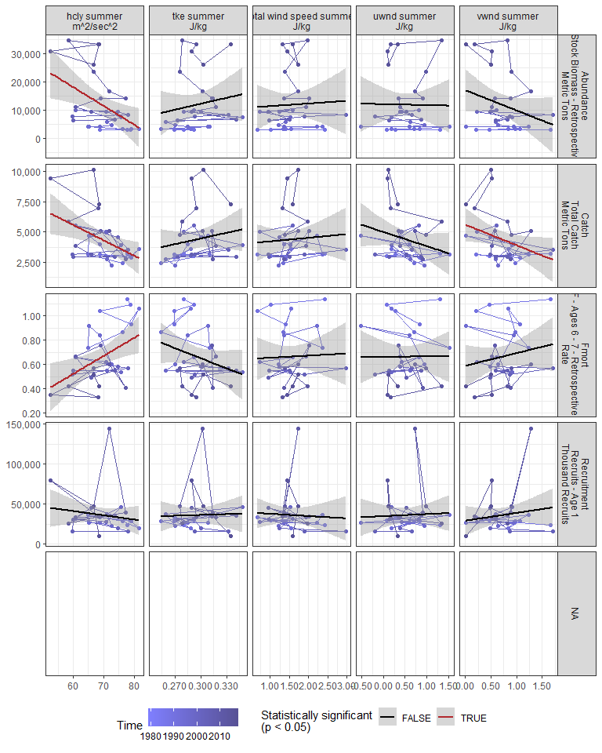

#### Regression statistics

Table 2.12: Catch vs hcly summer m2/sec2

|  |  |  |  |  |
| --- | --- | --- | --- | --- |
|  | Estimate | Std. Error | t value | Pr(>|t|) |
| (Intercept) | 13201.22 | 3175.90 | 4.16 | 0.00 |
| Val | -127.08 | 45.49 | -2.79 | 0.01 |

|  |  |
| --- | --- |
| Name | Value |
| F-statistic | 7.8 |
| df | 1, 28 |
| R2 | 0.22 |
| R2-adj | 0.19 |

Table 2.12: Catch vs vwnd summer J/kg

|  |  |  |  |  |
| --- | --- | --- | --- | --- |
|  | Estimate | Std. Error | t value | Pr(>|t|) |
| (Intercept) | 5599.38 | 686.23 | 8.16 | 0.00 |
| Val | -1703.64 | 830.36 | -2.05 | 0.05 |

|  |  |
| --- | --- |
| Name | Value |
| F-statistic | 4.21 |
| df | 1, 28 |
| R2 | 0.13 |
| R2-adj | 0.1 |

Table 2.12: Fmort vs hcly summer m2/sec2

|  |  |  |  |  |
| --- | --- | --- | --- | --- |
|  | Estimate | Std. Error | t value | Pr(>|t|) |
| (Intercept) | -0.37 | 0.37 | -1.00 | 0.32 |
| Val | 0.01 | 0.01 | 2.82 | 0.01 |

|  |  |
| --- | --- |
| Name | Value |
| F-statistic | 7.97 |
| df | 1, 28 |
| R2 | 0.22 |
| R2-adj | 0.19 |

Table 2.12: Abundance vs hcly summer m2/sec2

|  |  |  |  |  |
| --- | --- | --- | --- | --- |
|  | Estimate | Std. Error | t value | Pr(>|t|) |
| (Intercept) | 57832.49 | 16591.63 | 3.49 | 0.00 |
| Val | -661.64 | 237.63 | -2.78 | 0.01 |

|  |  |
| --- | --- |
| Name | Value |
| F-statistic | 7.75 |
| df | 1, 28 |
| R2 | 0.22 |
| R2-adj | 0.19 |

### 2.2.12 Fall wind speed

#### Figures

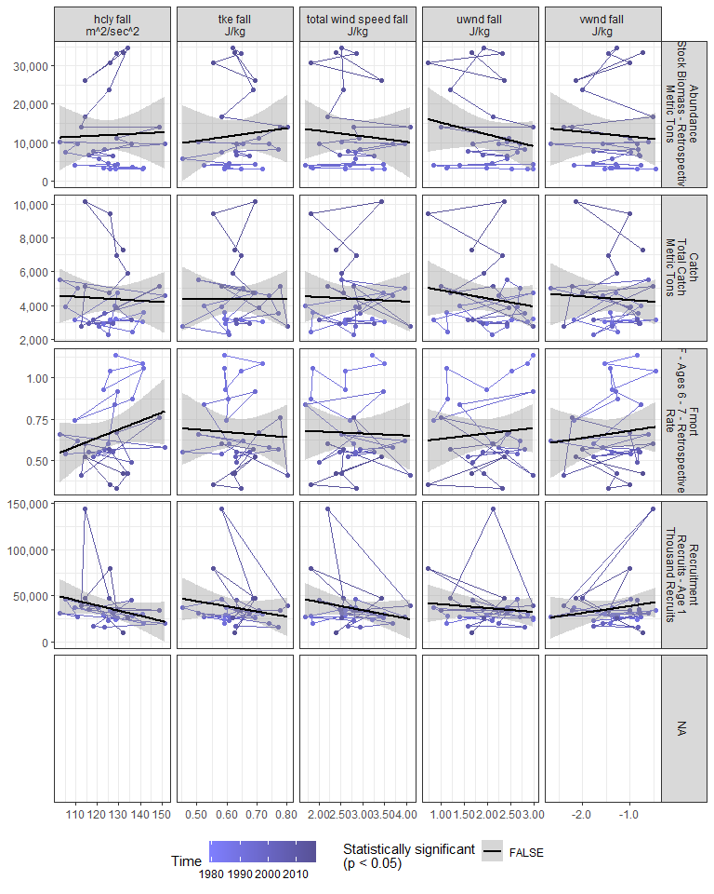

#### Regression statistics

[1] “No statistically significant data”

### 2.2.13 Gulf Stream Index

#### Figures

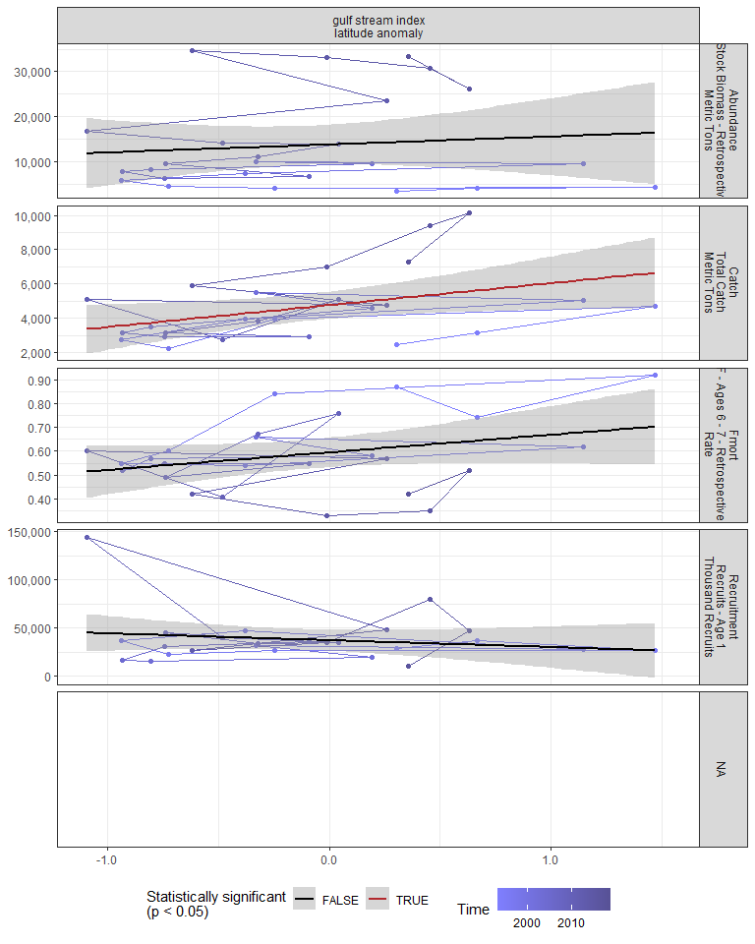

#### Regression statistics

Table 2.13: Catch vs gulf stream index latitude anomaly

|  |  |  |  |  |
| --- | --- | --- | --- | --- |
|  | Estimate | Std. Error | t value | Pr(>|t|) |
| (Intercept) | 4764.51 | 387.91 | 12.28 | 0.00 |
| Val | 1279.11 | 581.57 | 2.20 | 0.04 |

|  |  |
| --- | --- |
| Name | Value |
| F-statistic | 4.84 |
| df | 1, 23 |
| R2 | 0.17 |
| R2-adj | 0.14 |

### 2.2.14 North Atlantic Oscillation

#### Figures

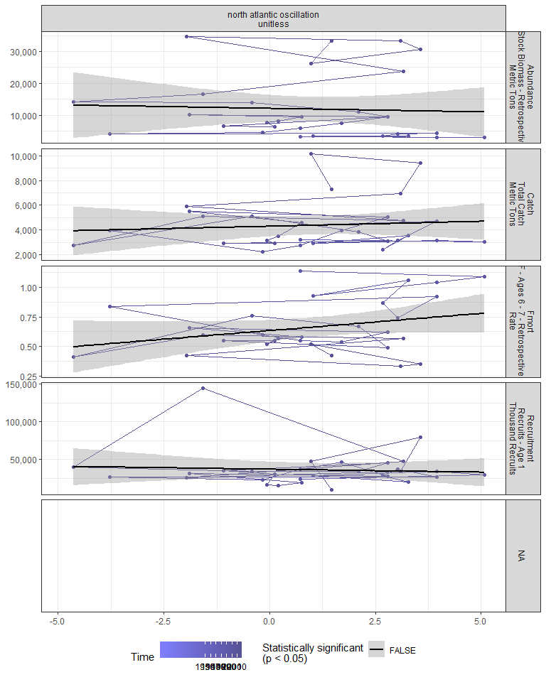

#### Regression statistics

[1] “No statistically significant data”

### 2.2.15 Northern range

Northernmost survey observation in each year.

#### Figures

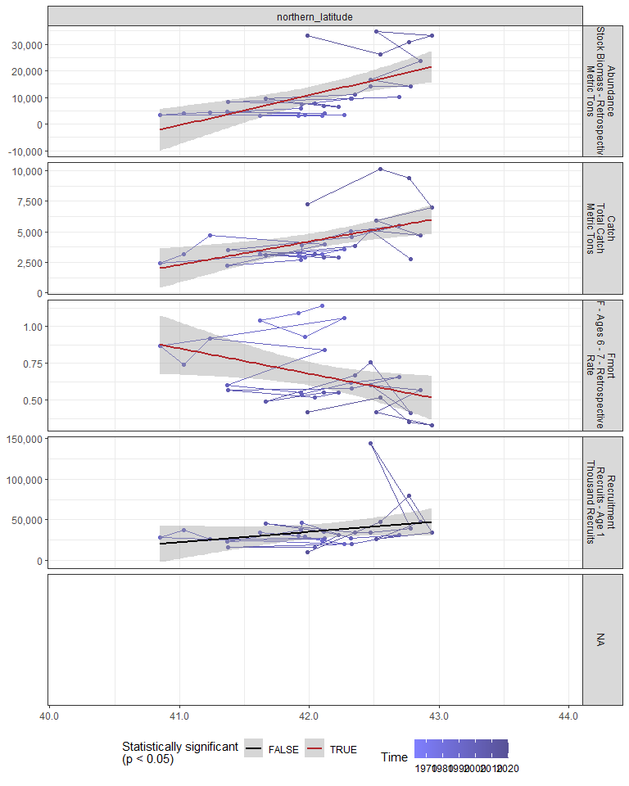

#### Regression statistics

Table 2.14: Catch vs northern_latitude

|  |  |  |  |  |
| --- | --- | --- | --- | --- |
|  | Estimate | Std. Error | t value | Pr(>|t|) |
| (Intercept) | -75719.07 | 24386.09 | -3.11 | 0 |
| Val | 1902.75 | 579.29 | 3.28 | 0 |

|  |  |
| --- | --- |
| Name | Value |
| F-statistic | 10.79 |
| df | 1, 28 |
| R2 | 0.28 |
| R2-adj | 0.25 |

Table 2.14: Fmort vs northern_latitude

|  |  |  |  |  |
| --- | --- | --- | --- | --- |
|  | Estimate | Std. Error | t value | Pr(>|t|) |
| (Intercept) | 7.90 | 3.04 | 2.60 | 0.01 |
| Val | -0.17 | 0.07 | -2.38 | 0.02 |

|  |  |
| --- | --- |
| Name | Value |
| F-statistic | 5.68 |
| df | 1, 28 |
| R2 | 0.17 |
| R2-adj | 0.14 |

Table 2.14: Abundance vs northern_latitude

|  |  |  |  |  |
| --- | --- | --- | --- | --- |
|  | Estimate | Std. Error | t value | Pr(>|t|) |
| (Intercept) | -464174.26 | 119818.27 | -3.87 | 0 |
| Val | 11309.31 | 2846.26 | 3.97 | 0 |

|  |  |
| --- | --- |
| Name | Value |
| F-statistic | 15.79 |
| df | 1, 28 |
| R2 | 0.36 |
| R2-adj | 0.34 |

### 2.2.16 Southern range

Southernmost survey observation in each year.

#### Figures

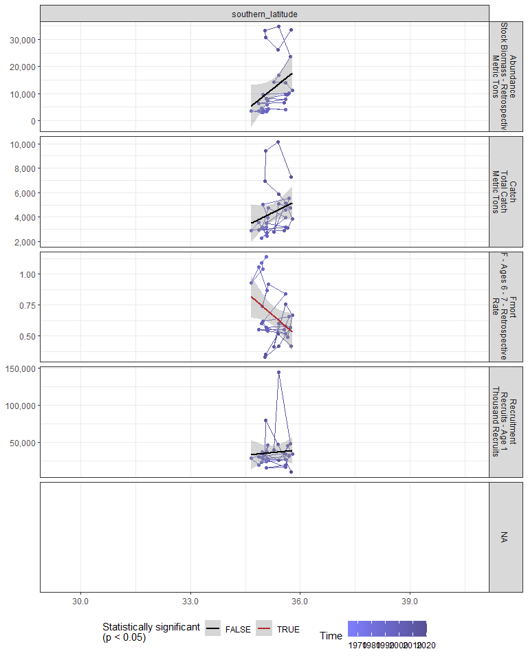

#### Regression statistics

Table 2.15: Fmort vs southern_latitude

|  |  |  |  |  |
| --- | --- | --- | --- | --- |
|  | Estimate | Std. Error | t value | Pr(>|t|) |
| (Intercept) | 9.63 | 4.31 | 2.24 | 0.03 |
| Val | -0.25 | 0.12 | -2.08 | 0.05 |

|  |  |
| --- | --- |
| Name | Value |
| F-statistic | 4.33 |
| df | 1, 28 |
| R2 | 0.13 |
| R2-adj | 0.1 |

## 2.3 Trophic indicators

### 2.3.1 Chlorophyll

#### Figures

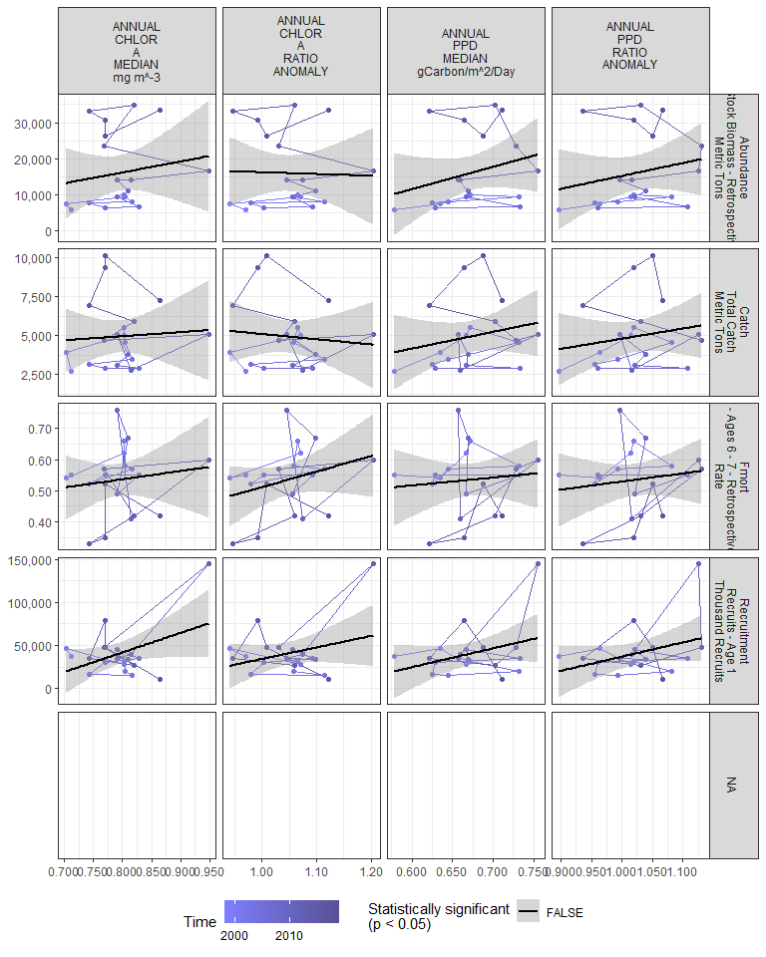

#### Regression statistics

[1] “No statistically significant data”

### 2.3.2 Chlorophyll in stock region

#### Figures

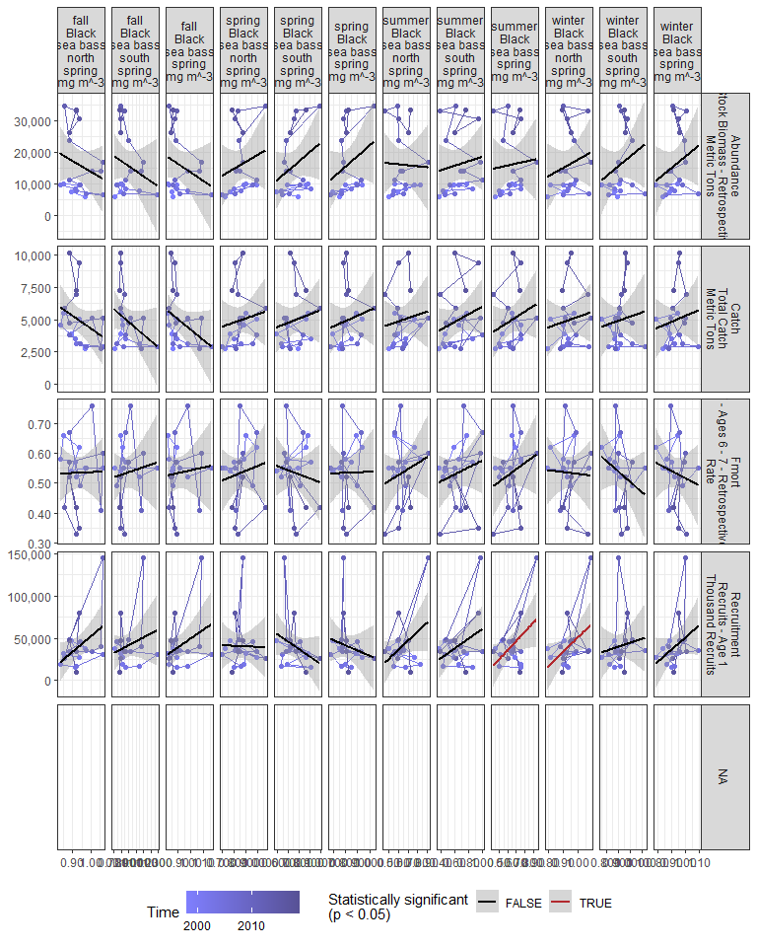

#### Regression statistics

Table 2.16: Recruitment vs summer Black sea bass spring mg m^-3

|  |  |  |  |  |
| --- | --- | --- | --- | --- |
|  | Estimate | Std. Error | t value | Pr(>|t|) |
| (Intercept) | -28544.2 | 31605.24 | -0.90 | 0.38 |
| Val | 107364.2 | 48477.41 | 2.21 | 0.04 |

|  |  |
| --- | --- |
| Name | Value |
| F-statistic | 4.91 |
| df | 1, 18 |
| R2 | 0.21 |
| R2-adj | 0.17 |

Table 2.16: Recruitment vs winter Black sea bass north spring mg m^-3

|  |  |  |  |  |
| --- | --- | --- | --- | --- |
|  | Estimate | Std. Error | t value | Pr(>|t|) |
| (Intercept) | -121723.3 | 76505.86 | -1.59 | 0.13 |
| Val | 172812.0 | 81387.83 | 2.12 | 0.05 |

|  |  |
| --- | --- |
| Name | Value |
| F-statistic | 4.51 |
| df | 1, 18 |
| R2 | 0.2 |
| R2-adj | 0.16 |

### 2.3.3 Primary production in stock region

#### Figures

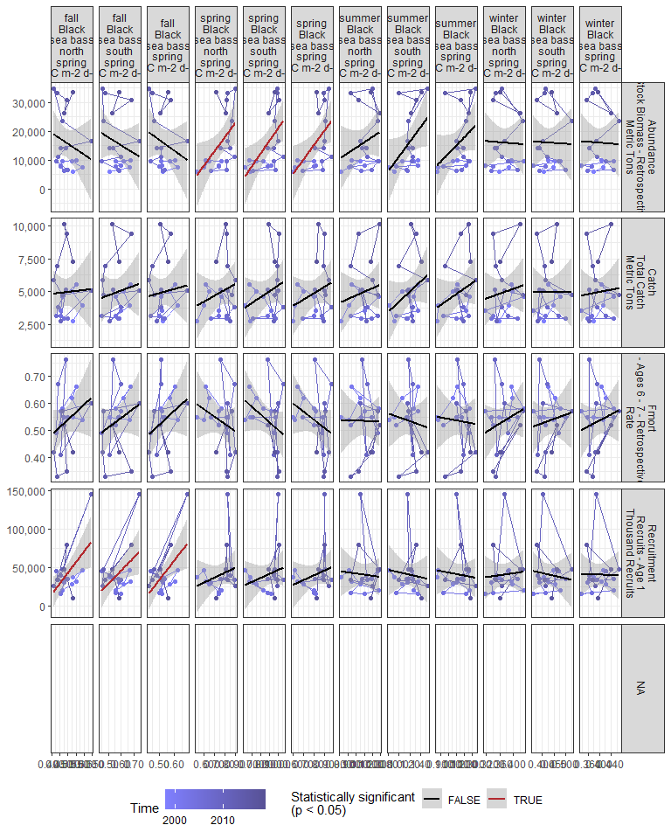

#### Regression statistics

Table 2.17: Recruitment vs fall Black sea bass north spring gC m-2 d-1

|  |  |  |  |  |
| --- | --- | --- | --- | --- |
|  | Estimate | Std. Error | t value | Pr(>|t|) |
| (Intercept) | -97574.38 | 48410.28 | -2.02 | 0.06 |
| Val | 280774.29 | 97995.79 | 2.87 | 0.01 |

|  |  |
| --- | --- |
| Name | Value |
| F-statistic | 8.21 |
| df | 1, 18 |
| R2 | 0.31 |
| R2-adj | 0.28 |

Table 2.17: Recruitment vs fall Black sea bass south spring gC m-2 d-1

|  |  |  |  |  |
| --- | --- | --- | --- | --- |
|  | Estimate | Std. Error | t value | Pr(>|t|) |
| (Intercept) | -56213.01 | 42101.47 | -1.34 | 0.20 |
| Val | 169708.37 | 73371.26 | 2.31 | 0.03 |

|  |  |
| --- | --- |
| Name | Value |
| F-statistic | 5.35 |
| df | 1, 18 |
| R2 | 0.23 |
| R2-adj | 0.19 |

Table 2.17: Recruitment vs fall Black sea bass spring gC m-2 d-1

|  |  |  |  |  |
| --- | --- | --- | --- | --- |
|  | Estimate | Std. Error | t value | Pr(>|t|) |
| (Intercept) | -90945.67 | 47064.48 | -1.93 | 0.07 |
| Val | 250326.64 | 89190.66 | 2.81 | 0.01 |

|  |  |
| --- | --- |
| Name | Value |
| F-statistic | 7.88 |
| df | 1, 18 |
| R2 | 0.3 |
| R2-adj | 0.27 |

Table 2.17: Abundance vs spring Black sea bass north spring gC m-2 d-1

|  |  |  |  |  |
| --- | --- | --- | --- | --- |
|  | Estimate | Std. Error | t value | Pr(>|t|) |
| (Intercept) | -21691.43 | 16068.51 | -1.35 | 0.19 |
| Val | 49572.17 | 20978.66 | 2.36 | 0.03 |

|  |  |
| --- | --- |
| Name | Value |
| F-statistic | 5.58 |
| df | 1, 18 |
| R2 | 0.24 |
| R2-adj | 0.19 |

Table 2.17: Abundance vs spring Black sea bass south spring gC m-2 d-1

|  |  |  |  |  |
| --- | --- | --- | --- | --- |
|  | Estimate | Std. Error | t value | Pr(>|t|) |
| (Intercept) | -23052.27 | 14087.82 | -1.64 | 0.12 |
| Val | 44053.74 | 15750.33 | 2.80 | 0.01 |

|  |  |
| --- | --- |
| Name | Value |
| F-statistic | 7.82 |
| df | 1, 18 |
| R2 | 0.3 |
| R2-adj | 0.26 |

Table 2.17: Abundance vs spring Black sea bass spring gC m-2 d-1

|  |  |  |  |  |
| --- | --- | --- | --- | --- |
|  | Estimate | Std. Error | t value | Pr(>|t|) |
| (Intercept) | -24312.65 | 15317.74 | -1.59 | 0.13 |
| Val | 49502.04 | 18664.82 | 2.65 | 0.02 |

|  |  |
| --- | --- |
| Name | Value |
| F-statistic | 7.03 |
| df | 1, 18 |
| R2 | 0.28 |
| R2-adj | 0.24 |

### 2.3.4 Spring zooplankton abundance by species

#### Figures

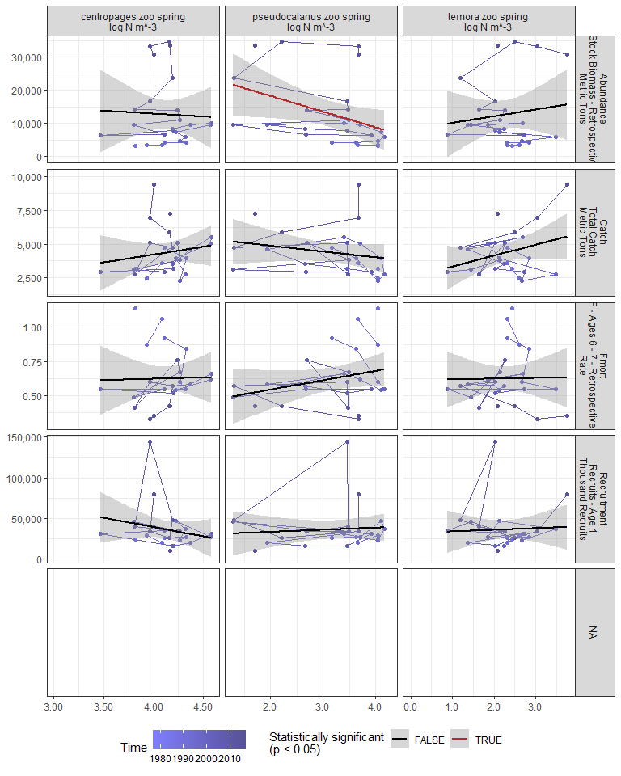

#### Regression statistics

Table 2.18: Abundance vs pseudocalanus zoo spring log N m^-3

|  |  |  |  |  |
| --- | --- | --- | --- | --- |
|  | Estimate | Std. Error | t value | Pr(>|t|) |
| (Intercept) | 27685.83 | 7254.53 | 3.82 | 0.00 |
| Val | -4728.25 | 2201.65 | -2.15 | 0.04 |

|  |  |
| --- | --- |
| Name | Value |
| F-statistic | 4.61 |
| df | 1, 23 |
| R2 | 0.17 |
| R2-adj | 0.13 |

### 2.3.5 Fall zooplankton abundance by species

#### Figures

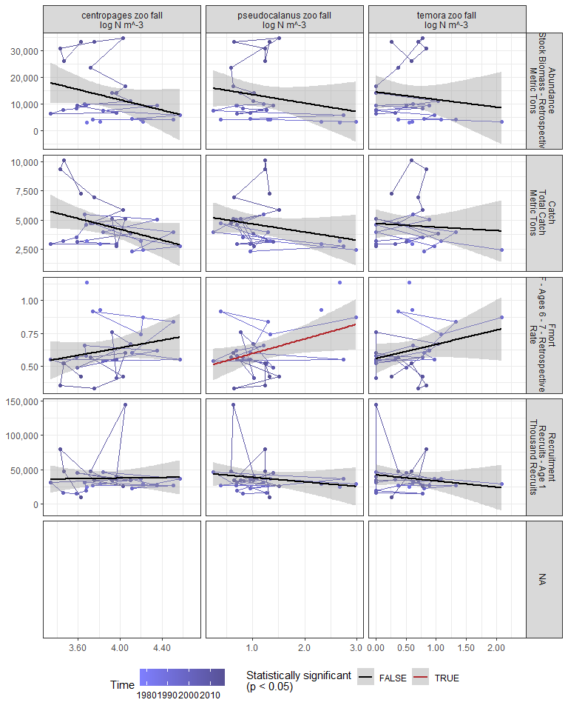

#### Regression statistics

Table 2.19: Fmort vs pseudocalanus zoo fall log N m^-3

|  |  |  |  |  |
| --- | --- | --- | --- | --- |
|  | Estimate | Std. Error | t value | Pr(>|t|) |
| (Intercept) | 0.49 | 0.07 | 7.10 | 0.00 |
| Val | 0.11 | 0.05 | 2.27 | 0.03 |

|  |  |
| --- | --- |
| Name | Value |
| F-statistic | 5.13 |
| df | 1, 25 |
| R2 | 0.17 |
| R2-adj | 0.14 |

### 2.3.6 Zooplankton abundance by group

#### Figures

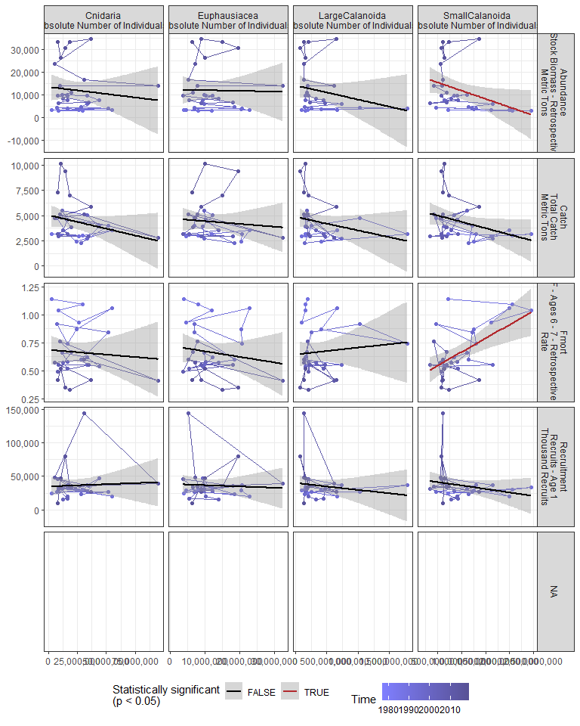

#### Regression statistics

Table 2.20: Fmort vs SmallCalanoida Absolute Number of Individuals

|  |  |  |  |  |
| --- | --- | --- | --- | --- |
|  | Estimate | Std. Error | t value | Pr(>|t|) |
| (Intercept) | 0.42 | 0.07 | 5.77 | 0 |
| Val | 0.00 | 0.00 | 3.68 | 0 |

|  |  |
| --- | --- |
| Name | Value |
| F-statistic | 13.51 |
| df | 1, 28 |
| R2 | 0.33 |
| R2-adj | 0.3 |

Table 2.20: Abundance vs SmallCalanoida Absolute Number of Individuals

|  |  |  |  |  |
| --- | --- | --- | --- | --- |
|  | Estimate | Std. Error | t value | Pr(>|t|) |
| (Intercept) | 18989.93 | 3735.35 | 5.08 | 0.00 |
| Val | 0.00 | 0.00 | -2.16 | 0.04 |

|  |  |
| --- | --- |
| Name | Value |
| F-statistic | 4.65 |
| df | 1, 28 |
| R2 | 0.14 |
| R2-adj | 0.11 |

### 2.3.7 Abundance of Calanus CV and adults

#### Figures

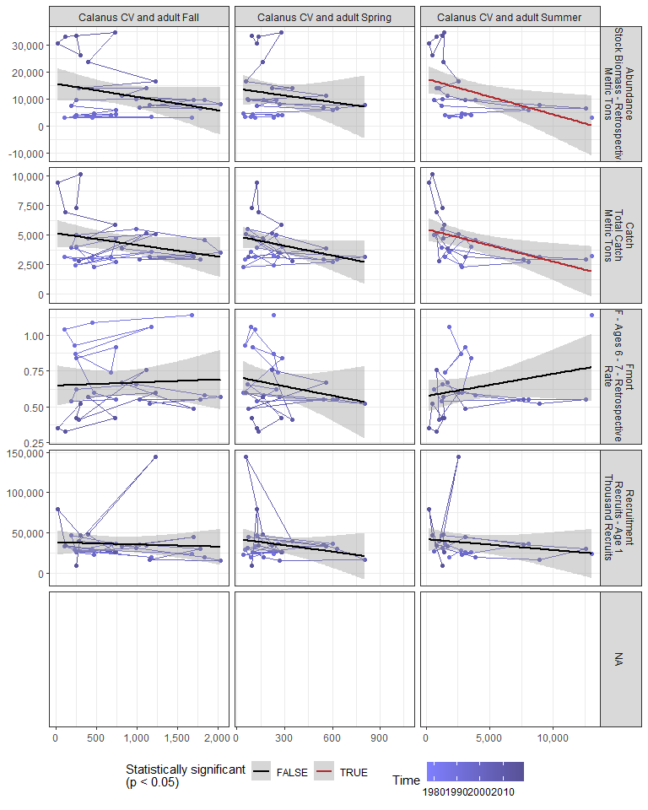

#### Regression statistics

Table 2.21: Catch vs Calanus CV and adult Summer

|  |  |  |  |  |
| --- | --- | --- | --- | --- |
|  | Estimate | Std. Error | t value | Pr(>|t|) |
| (Intercept) | 5487.59 | 490.63 | 11.18 | 0.00 |
| Val | -0.27 | 0.10 | -2.74 | 0.01 |

|  |  |
| --- | --- |
| Name | Value |
| F-statistic | 7.49 |
| df | 1, 24 |
| R2 | 0.24 |
| R2-adj | 0.21 |

Table 2.21: Abundance vs Calanus CV and adult Summer

|  |  |  |  |  |
| --- | --- | --- | --- | --- |
|  | Estimate | Std. Error | t value | Pr(>|t|) |
| (Intercept) | 17493.05 | 2569.88 | 6.81 | 0.00 |
| Val | -1.33 | 0.53 | -2.53 | 0.02 |

|  |  |
| --- | --- |
| Name | Value |
| F-statistic | 6.39 |
| df | 1, 24 |
| R2 | 0.21 |
| R2-adj | 0.18 |

### 2.3.8 Zooplankton abundance anomaly

#### Figures

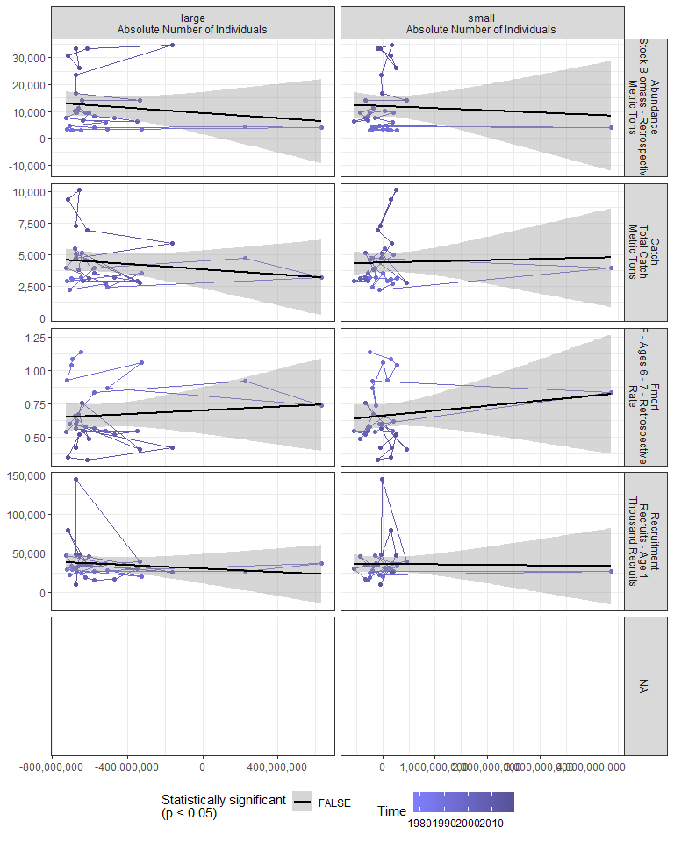

#### Regression statistics

[1] “No statistically significant data”

### 2.3.9 Zooplankton diversity index

#### Figures

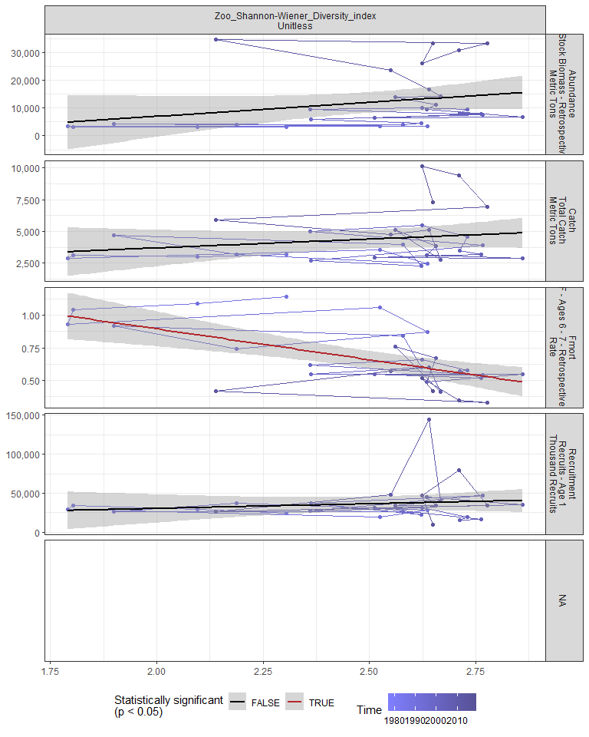

#### Regression statistics

Table 2.22: Fmort vs Zoo_Shannon-Wiener_Diversity_index Unitless

|  |  |  |  |  |
| --- | --- | --- | --- | --- |
|  | Estimate | Std. Error | t value | Pr(>|t|) |
| (Intercept) | 1.84 | 0.29 | 6.36 | 0 |
| Val | -0.47 | 0.12 | -4.10 | 0 |

|  |  |
| --- | --- |
| Name | Value |
| F-statistic | 16.78 |
| df | 1, 28 |
| R2 | 0.37 |
| R2-adj | 0.35 |

### 2.3.10 Small/large copepod anomaly

#### Figures

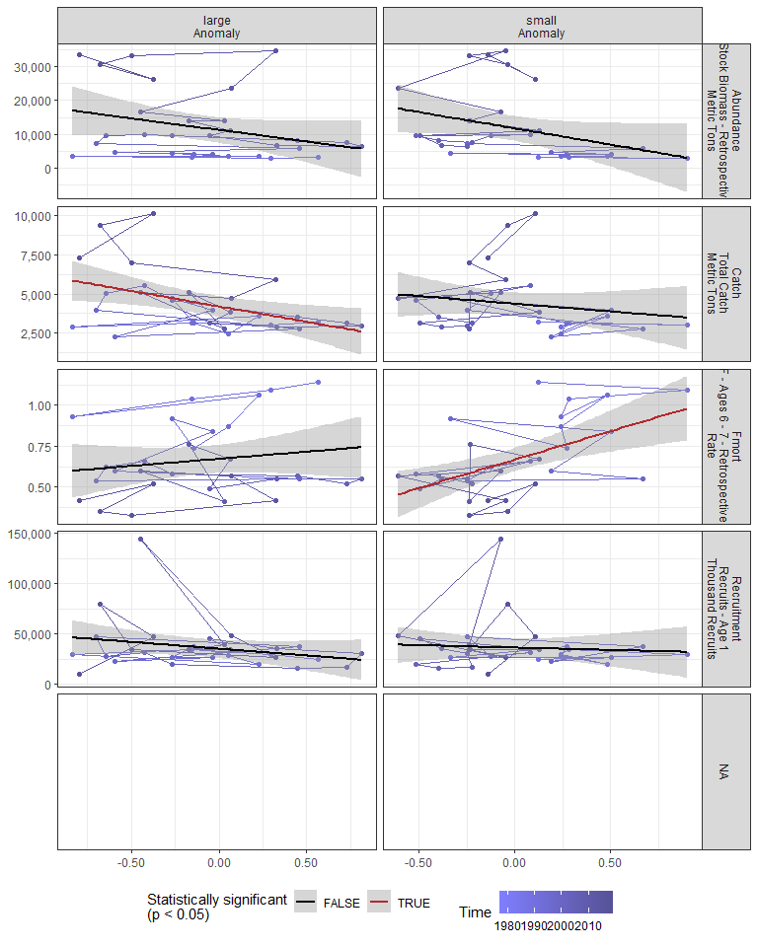

#### Regression statistics

Table 2.23: Catch vs large Anomaly

|  |  |  |  |  |
| --- | --- | --- | --- | --- |
|  | Estimate | Std. Error | t value | Pr(>|t|) |
| (Intercept) | 4198.72 | 327.22 | 12.83 | 0.00 |
| Val | -1975.31 | 712.08 | -2.77 | 0.01 |

|  |  |
| --- | --- |
| Name | Value |
| F-statistic | 7.7 |
| df | 1, 28 |
| R2 | 0.22 |
| R2-adj | 0.19 |

Table 2.23: Fmort vs small Anomaly

|  |  |  |  |  |
| --- | --- | --- | --- | --- |
|  | Estimate | Std. Error | t value | Pr(>|t|) |
| (Intercept) | 0.67 | 0.04 | 19.08 | 0 |
| Val | 0.35 | 0.10 | 3.53 | 0 |

|  |  |
| --- | --- |
| Name | Value |
| F-statistic | 12.45 |
| df | 1, 28 |
| R2 | 0.31 |
| R2-adj | 0.28 |

### 2.3.11 Ichthyoplankton diversity

#### Figures

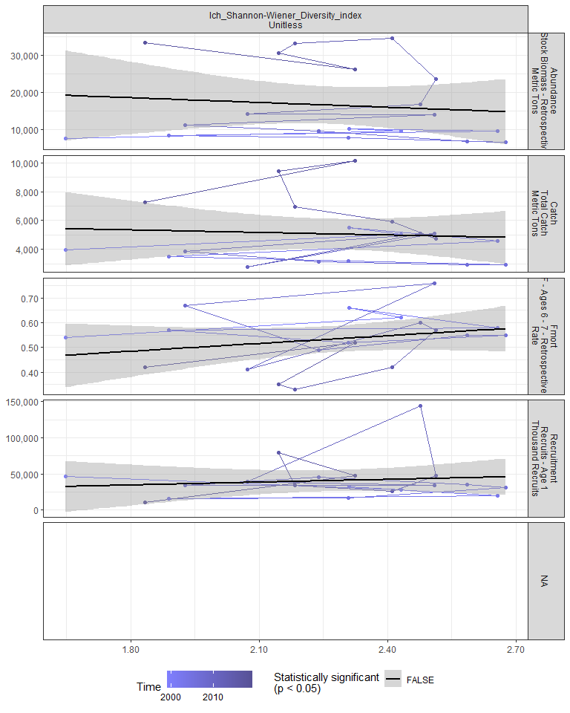

#### Regression statistics

[1] “No statistically significant data”

### 2.3.12 Forage fish abundance

#### Figures

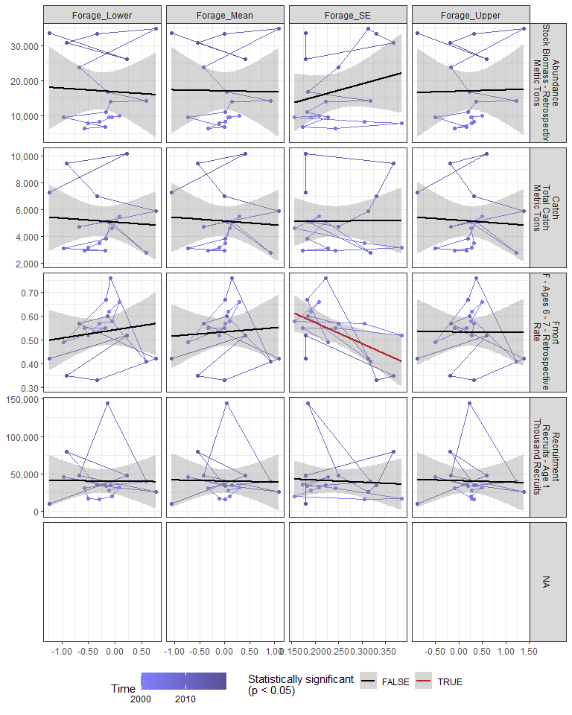

#### Regression statistics

Table 2.24: Fmort vs Forage_SE

|  |  |  |  |  |
| --- | --- | --- | --- | --- |
|  | Estimate | Std. Error | t value | Pr(>|t|) |
| (Intercept) | 0.75 | 0.08 | 9.06 | 0.00 |
| Val | -0.89 | 0.32 | -2.73 | 0.01 |

|  |  |
| --- | --- |
| Name | Value |
| F-statistic | 7.47 |
| df | 1, 16 |
| R2 | 0.32 |
| R2-adj | 0.28 |

### 2.3.13 Species distribution

#### Figures

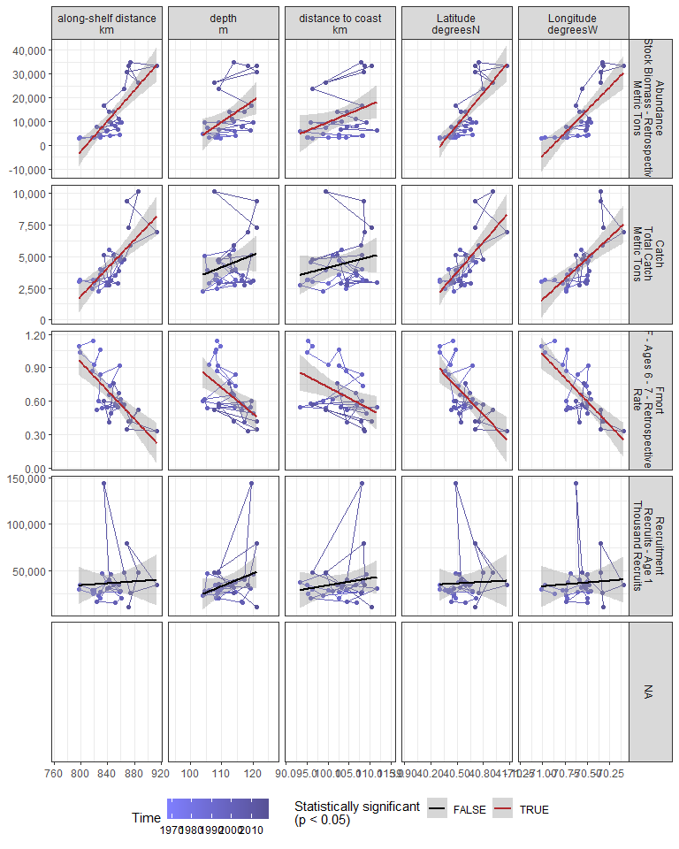

#### Regression statistics

Table 2.25: Catch vs along-shelf distance km

|  |  |  |  |  |
| --- | --- | --- | --- | --- |
|  | Estimate | Std. Error | t value | Pr(>|t|) |
| (Intercept) | -42302.73 | 8777.68 | -4.82 | 0 |
| Val | 55.25 | 10.39 | 5.32 | 0 |

|  |  |
| --- | --- |
| Name | Value |
| F-statistic | 28.3 |
| df | 1, 28 |
| R2 | 0.5 |
| R2-adj | 0.48 |

Table 2.25: Catch vs Latitude degreesN

|  |  |  |  |  |
| --- | --- | --- | --- | --- |
|  | Estimate | Std. Error | t value | Pr(>|t|) |
| (Intercept) | -319031.69 | 61804.05 | -5.16 | 0 |
| Val | 7970.74 | 1523.23 | 5.23 | 0 |

|  |  |
| --- | --- |
| Name | Value |
| F-statistic | 27.38 |
| df | 1, 28 |
| R2 | 0.49 |
| R2-adj | 0.48 |

Table 2.25: Catch vs Longitude degreesW

|  |  |  |  |  |
| --- | --- | --- | --- | --- |
|  | Estimate | Std. Error | t value | Pr(>|t|) |
| (Intercept) | 466397.08 | 98581.22 | 4.73 | 0 |
| Val | 6546.14 | 1396.74 | 4.69 | 0 |

|  |  |
| --- | --- |
| Name | Value |
| F-statistic | 21.97 |
| df | 1, 28 |
| R2 | 0.44 |
| R2-adj | 0.42 |

Table 2.25: Fmort vs along-shelf distance km

|  |  |  |  |  |
| --- | --- | --- | --- | --- |
|  | Estimate | Std. Error | t value | Pr(>|t|) |
| (Intercept) | 6.03 | 1.03 | 5.86 | 0 |
| Val | -0.01 | 0.00 | -5.22 | 0 |

|  |  |
| --- | --- |
| Name | Value |
| F-statistic | 27.24 |
| df | 1, 28 |
| R2 | 0.49 |
| R2-adj | 0.48 |

Table 2.25: Fmort vs Latitude degreesN

|  |  |  |  |  |
| --- | --- | --- | --- | --- |
|  | Estimate | Std. Error | t value | Pr(>|t|) |
| (Intercept) | 34.22 | 7.84 | 4.36 | 0 |
| Val | -0.83 | 0.19 | -4.28 | 0 |

|  |  |
| --- | --- |
| Name | Value |
| F-statistic | 18.31 |
| df | 1, 28 |
| R2 | 0.4 |
| R2-adj | 0.37 |

Table 2.25: Fmort vs Longitude degreesW

|  |  |  |  |  |
| --- | --- | --- | --- | --- |
|  | Estimate | Std. Error | t value | Pr(>|t|) |
| (Intercept) | -59.23 | 10.26 | -5.77 | 0 |
| Val | -0.85 | 0.15 | -5.84 | 0 |

|  |  |
| --- | --- |
| Name | Value |
| F-statistic | 34.06 |
| df | 1, 28 |
| R2 | 0.55 |
| R2-adj | 0.53 |

Table 2.25: Fmort vs depth m

|  |  |  |  |  |
| --- | --- | --- | --- | --- |
|  | Estimate | Std. Error | t value | Pr(>|t|) |
| (Intercept) | 3.25 | 0.78 | 4.17 | 0 |
| Val | -0.02 | 0.01 | -3.33 | 0 |

|  |  |
| --- | --- |
| Name | Value |
| F-statistic | 11.07 |
| df | 1, 28 |
| R2 | 0.28 |
| R2-adj | 0.26 |

Table 2.25: Fmort vs distance to coast km

|  |  |  |  |  |
| --- | --- | --- | --- | --- |
|  | Estimate | Std. Error | t value | Pr(>|t|) |
| (Intercept) | 2.69 | 0.76 | 3.56 | 0.00 |
| Val | -0.02 | 0.01 | -2.69 | 0.01 |

|  |  |
| --- | --- |
| Name | Value |
| F-statistic | 7.21 |
| df | 1, 28 |
| R2 | 0.2 |
| R2-adj | 0.18 |

Table 2.25: Abundance vs along-shelf distance km

|  |  |  |  |  |
| --- | --- | --- | --- | --- |
|  | Estimate | Std. Error | t value | Pr(>|t|) |
| (Intercept) | -256928.6 | 40489.81 | -6.35 | 0 |
| Val | 318.2 | 47.91 | 6.64 | 0 |

|  |  |
| --- | --- |
| Name | Value |
| F-statistic | 44.11 |
| df | 1, 28 |
| R2 | 0.61 |
| R2-adj | 0.6 |

Table 2.25: Abundance vs Latitude degreesN

|  |  |  |  |  |
| --- | --- | --- | --- | --- |
|  | Estimate | Std. Error | t value | Pr(>|t|) |
| (Intercept) | -1823618.58 | 292531.51 | -6.23 | 0 |
| Val | 45237.98 | 7209.74 | 6.27 | 0 |

|  |  |
| --- | --- |
| Name | Value |
| F-statistic | 39.37 |
| df | 1, 28 |
| R2 | 0.58 |
| R2-adj | 0.57 |

Table 2.25: Abundance vs Longitude degreesW

|  |  |  |  |  |
| --- | --- | --- | --- | --- |
|  | Estimate | Std. Error | t value | Pr(>|t|) |
| (Intercept) | 2727010.57 | 457526.1 | 5.96 | 0 |
| Val | 38469.23 | 6482.4 | 5.93 | 0 |

|  |  |
| --- | --- |
| Name | Value |
| F-statistic | 35.22 |
| df | 1, 28 |
| R2 | 0.56 |
| R2-adj | 0.54 |

Table 2.25: Abundance vs depth m

|  |  |  |  |  |
| --- | --- | --- | --- | --- |
|  | Estimate | Std. Error | t value | Pr(>|t|) |
| (Intercept) | -88012.35 | 36859.04 | -2.39 | 0.02 |
| Val | 888.82 | 327.65 | 2.71 | 0.01 |

|  |  |
| --- | --- |
| Name | Value |
| F-statistic | 7.36 |
| df | 1, 28 |
| R2 | 0.21 |
| R2-adj | 0.18 |

Table 2.25: Abundance vs distance to coast km

|  |  |  |  |  |
| --- | --- | --- | --- | --- |
|  | Estimate | Std. Error | t value | Pr(>|t|) |
| (Intercept) | -63089.82 | 35460.10 | -1.78 | 0.09 |
| Val | 727.37 | 343.65 | 2.12 | 0.04 |

|  |  |
| --- | --- |
| Name | Value |
| F-statistic | 4.48 |
| df | 1, 28 |
| R2 | 0.14 |
| R2-adj | 0.11 |

## 2.4 Larvae and YOY indicators

### 2.4.1 Recruitment

#### Figures

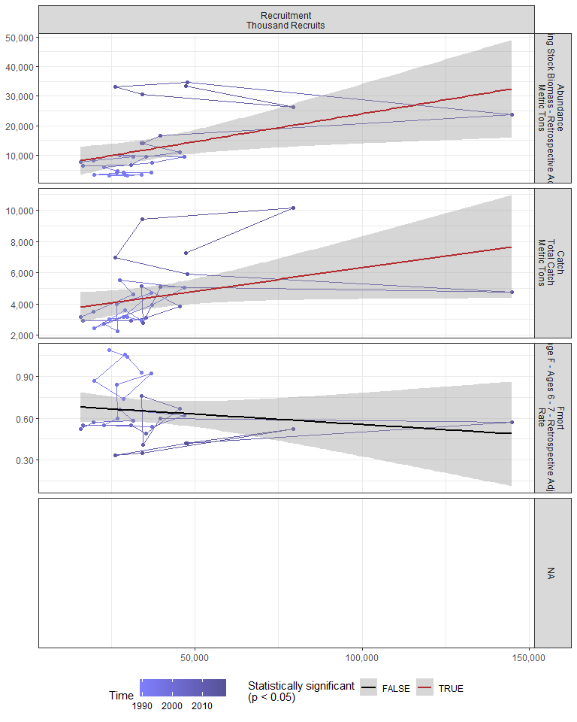

#### Regression statistics

Table 2.26: Catch vs Recruitment Thousand Recruits

|  |  |  |  |  |
| --- | --- | --- | --- | --- |
|  | Estimate | Std. Error | t value | Pr(>|t|) |
| (Intercept) | 3298.04 | 642.76 | 5.13 | 0.00 |
| Val | 0.03 | 0.01 | 2.06 | 0.05 |

|  |  |
| --- | --- |
| Name | Value |
| F-statistic | 4.26 |
| df | 1, 27 |
| R2 | 0.14 |
| R2-adj | 0.1 |

Table 2.26: Abundance vs Recruitment Thousand Recruits

|  |  |  |  |  |
| --- | --- | --- | --- | --- |
|  | Estimate | Std. Error | t value | Pr(>|t|) |
| (Intercept) | 5196.06 | 3212.70 | 1.62 | 0.12 |
| Val | 0.19 | 0.07 | 2.58 | 0.02 |

|  |  |
| --- | --- |
| Name | Value |
| F-statistic | 6.65 |
| df | 1, 27 |
| R2 | 0.2 |
| R2-adj | 0.17 |

### 2.4.2 Larval growth

## 2.5 Juvenile indicators

### 2.5.1 Length-age curves

### 2.5.2 Condition

### 2.5.3 CPUE

## 2.6 Adult indicators

### 2.6.1 Abundance

#### Figures

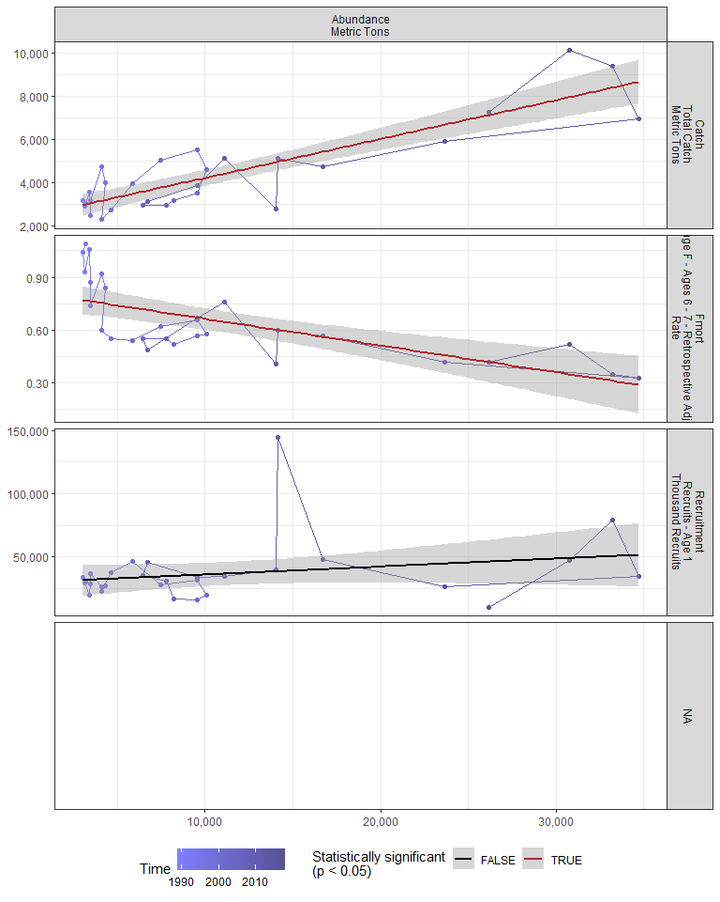

#### Regression statistics

Table 2.27: Catch vs Abundance Metric Tons

|  |  |  |  |  |
| --- | --- | --- | --- | --- |
|  | Estimate | Std. Error | t value | Pr(>|t|) |
| (Intercept) | 2402.56 | 285.15 | 8.43 | 0 |
| Val | 0.18 | 0.02 | 9.21 | 0 |

|  |  |
| --- | --- |
| Name | Value |
| F-statistic | 84.85 |
| df | 1, 27 |
| R2 | 0.76 |
| R2-adj | 0.75 |

Table 2.27: Fmort vs Abundance Metric Tons

|  |  |  |  |  |
| --- | --- | --- | --- | --- |
|  | Estimate | Std. Error | t value | Pr(>|t|) |
| (Intercept) | 0.82 | 0.05 | 17.90 | 0 |
| Val | 0.00 | 0.00 | -4.83 | 0 |

|  |  |
| --- | --- |
| Name | Value |
| F-statistic | 23.29 |
| df | 1, 27 |
| R2 | 0.46 |
| R2-adj | 0.44 |

### 2.6.2 Mean age of spawning stock

### 2.6.3 Age distribution

### 2.6.4 Length-age curves

### 2.6.5 Condition

#### Figures

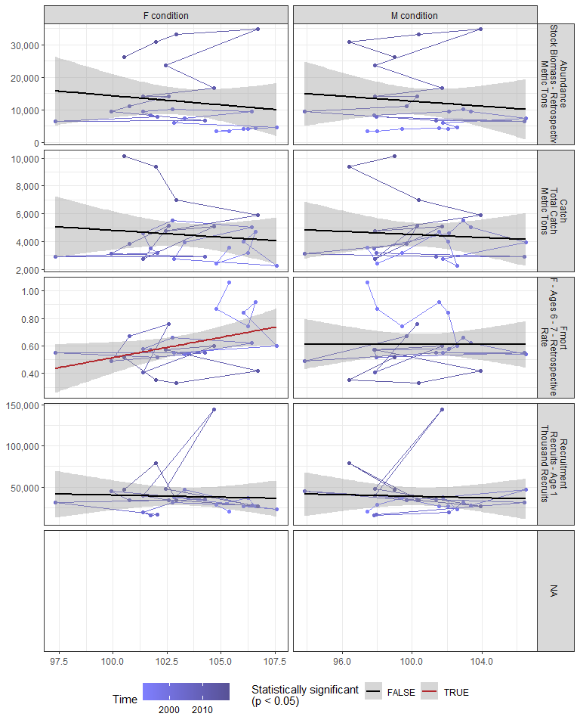

#### Regression statistics

Table 2.28: Fmort vs F condition

|  |  |  |  |  |
| --- | --- | --- | --- | --- |
|  | Estimate | Std. Error | t value | Pr(>|t|) |
| (Intercept) | -2.43 | 1.36 | -1.79 | 0.09 |
| Val | 0.03 | 0.01 | 2.24 | 0.04 |

|  |  |
| --- | --- |
| Name | Value |
| F-statistic | 5.01 |
| df | 1, 23 |
| R2 | 0.18 |
| R2-adj | 0.14 |

### 2.6.6 Stomach fullness

#### Figures

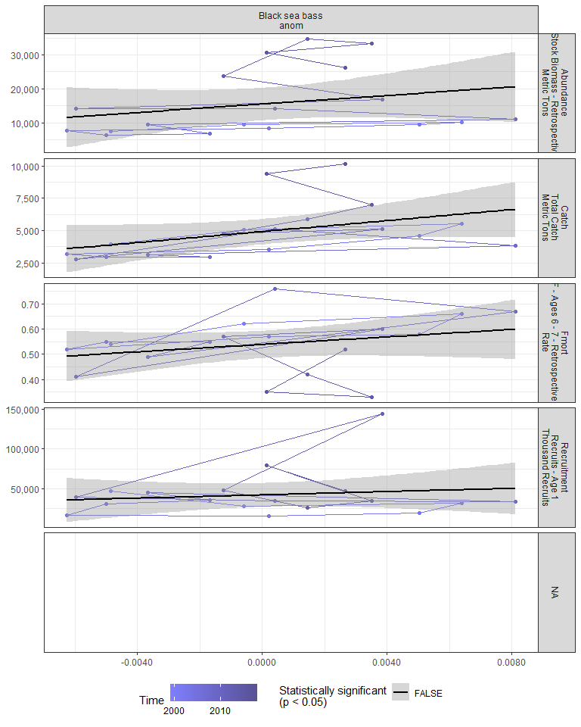

#### Regression statistics

[1] “No statistically significant data”

### 2.6.7 Center of gravity and area occupied

## 2.7 Socioeconomic indicators

### 2.7.1 CPUE by catch strategy

### 2.7.2 Recreational CPUE

#### Figures

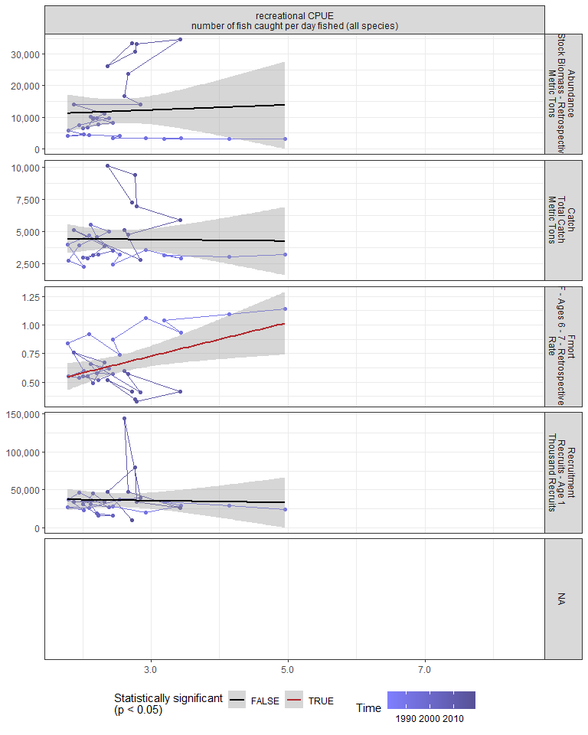

#### Regression statistics

Table 2.29: Fmort vs recreational CPUE number of fish caught per day fished (all species)

|  |  |  |  |  |
| --- | --- | --- | --- | --- |
|  | Estimate | Std. Error | t value | Pr(>|t|) |
| (Intercept) | 0.29 | 0.14 | 1.98 | 0.06 |
| Val | 0.15 | 0.05 | 2.72 | 0.01 |

|  |  |
| --- | --- |
| Name | Value |
| F-statistic | 7.4 |
| df | 1, 28 |
| R2 | 0.21 |
| R2-adj | 0.18 |

# 3 Summary of statistically significant indicators

## 3.1 Abundance

|  |  |  |  |  |
| --- | --- | --- | --- | --- |
| Indicator | Number of data points | Slope | P-value | R2_adj |
| Time | 29 | 1000 | 1.3e-09 | 0.74 |
| cumulative intensity |  |  |  |  |
| degrees C | 25 | 51 | 0.0017 | 0.33 |
| GLORYS bottom temp anomaly |  |  |  |  |
| degreesC | 25 | 6400 | 0.002 | 0.32 |
| long-term sst |  |  |  |  |
| degreesC | 30 | 11000 | 3e-06 | 0.53 |
| fall OI SST Anomaly |  |  |  |  |
| degreesC | 30 | 9000 | 6.6e-05 | 0.42 |
| spring OI SST Anomaly |  |  |  |  |
| degreesC | 30 | 6500 | 0.0045 | 0.23 |
| summer OI SST Anomaly |  |  |  |  |
| degreesC | 30 | 8100 | 0.00037 | 0.35 |
| fall |  |  |  |  |

OI SST Anomaly Black sea bass north spring degreesC |30 |8100 |6.1e-06 |0.51 | |fall OI SST Anomaly Black sea bass south spring degreesC |30 |7500 |0.0016 |0.28 | |fall OI SST Anomaly Black sea bass spring degreesC |30 |8600 |3e-05 |0.45 | |spring OI SST Anomaly Black sea bass north spring degreesC |30 |7800 |0.0026 |0.26 | |summer OI SST Anomaly Black sea bass north spring degreesC |30 |7600 |3e-04 |0.36 | |summer OI SST Anomaly Black sea bass south spring degreesC |30 |7100 |0.0046 |0.23 | |summer OI SST Anomaly Black sea bass spring degreesC |30 |8100 |0.00051 |0.33 | |winter OI SST Anomaly Black sea bass north spring degreesC |30 |6000 |0.0033 |0.24 | |winter OI SST Anomaly Black sea bass spring degreesC |30 |4700 |0.024 |0.14 | |spring OI SST Anomaly Black sea bass spring degreesC |30 |6000 |0.015 |0.16 | |tke winter J/kg |30 |57000 |0.015 |0.17 | |hcly summer m2/sec2 |30 |-660 |0.0095 |0.19 | |northern_latitude |30 |11000 |0.00045 |0.34 | |spring Black sea bass north spring gC m-2 d-1 |20 |50000 |0.03 |0.19 | |spring Black sea bass south spring gC m-2 d-1 |20 |44000 |0.012 |0.26 | |spring Black sea bass spring gC m-2 d-1 |20 |50000 |0.016 |0.24 | |pseudocalanus zoo spring log N m^-3 |30 |-4700 |0.043 |0.13 | |SmallCalanoida Absolute Number of Individuals |30 |-7.3e-06 |0.04 |0.11 | |Calanus CV and adult Summer |27 |-1.3 |0.018 |0.18 | |along-shelf distance km |30 |320 |3.3e-07 |0.6 | |Latitude degreesN |30 |45000 |8.8e-07 |0.57 | |Longitude degreesW |30 |38000 |2.2e-06 |0.54 | |depth m |30 |890 |0.011 |0.18 | |distance to coast km |30 |730 |0.043 |0.11 | |Recruitment Thousand Recruits |29 |0.19 |0.016 |0.17 |

### 3.1.1 Generalized linear model

This is an exploratory fit of a poisson GLM. Initial covariates were included based on statistical significance at a Bonferroni-corrected alpha in the linear correlations shown in this report. Final covariates were chosen by forward stepwise AIC selection of additive GLMs.

|  |  |  |  |  |
| --- | --- | --- | --- | --- |
| rnames | Estimate | Std. Error | z value | Pr(>|z|) |
| (Intercept) | -212 | 12.9 | -16.5 | 6.04e-61 |
| Longitude_degreesW | -11.8 | 0.496 | -23.8 | 7.18e-125 |
| long_term_sst_degreesC | 0.371 | 0.00621 | 59.7 | 0 |
| northern_latitude | 0.335 | 0.00611 | 54.9 | 0 |
| Latitude_degreesN | -20.4 | 0.735 | -27.8 | 7.01e-170 |
| along_shelf_distance_km | 0.236 | 0.00868 | 27.1 | 2.58e-162 |
| fall_OI_SST_Anomaly_Black_sea_bass_north_spring_degreesC | -0.258 | 0.0213 | -12.1 | 7.28e-34 |
| summer_OI_SST_Anomaly_Black_sea_bass_spring_degreesC | -5.5 | 0.0657 | -83.6 | 0 |
| summer_OI_SST_Anomaly_degreesC | 3.35 | 0.0424 | 79.1 | 0 |
| summer_OI_SST_Anomaly_Black_sea_bass_north_spring_degreesC | 2.07 | 0.0277 | 74.8 | 0 |
| fall_OI_SST_Anomaly_Black_sea_bass_spring_degreesC | 1.16 | 0.0715 | 16.2 | 5.09e-59 |
| fall_OI_SST_Anomaly_degreesC | -0.817 | 0.054 | -15.1 | 1.32e-51 |

Dropped coefficients: none

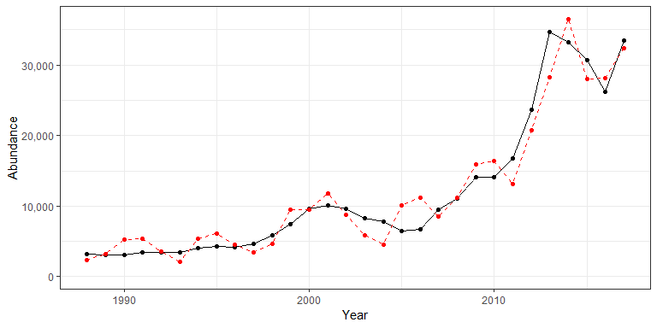

## 3.2 Recruitment

|  |  |  |  |  |
| --- | --- | --- | --- | --- |
| Indicator | Number of data points | Slope | P-value | R2_adj |
| cumulative intensity |  |  |  |  |
| degrees C | 25 | 90 | 0.033 | 0.15 |
| fall OI SST Anomaly |  |  |  |  |
| degreesC | 30 | 14000 | 0.02 | 0.15 |
| spring OI SST Anomaly |  |  |  |  |
| degreesC | 30 | 14000 | 0.0098 | 0.19 |
| summer OI SST Anomaly |  |  |  |  |
| degreesC | 30 | 14000 | 0.014 | 0.17 |
| fall |  |  |  |  |

OI SST Anomaly Black sea bass north spring degreesC |30 |11000 |0.019 |0.15 | |fall OI SST Anomaly Black sea bass spring degreesC |30 |12000 |0.022 |0.14 | |spring OI SST Anomaly Black sea bass north spring degreesC |30 |14000 |0.029 |0.13 | |summer OI SST Anomaly Black sea bass north spring degreesC |30 |11000 |0.045 |0.11 | |summer OI SST Anomaly Black sea bass south spring degreesC |30 |15000 |0.011 |0.18 | |summer OI SST Anomaly Black sea bass spring degreesC |30 |14000 |0.021 |0.15 | |spring OI SST Anomaly Black sea bass south spring degreesC |30 |11000 |0.022 |0.14 | |spring OI SST Anomaly Black sea bass spring degreesC |30 |14000 |0.017 |0.16 | |summer Black sea bass spring mg m^-3 |20 |110000 |0.04 |0.17 | |winter Black sea bass north spring mg m^-3 |20 |170000 |0.048 |0.16 | |fall Black sea bass north spring gC m-2 d-1 |20 |280000 |0.01 |0.28 | |fall Black sea bass south spring gC m-2 d-1 |20 |170000 |0.033 |0.19 | |fall Black sea bass spring gC m-2 d-1 |20 |250000 |0.012 |0.27 |

### 3.2.1 Generalized linear model

This is an exploratory fit of a poisson GLM. Initial covariates were included based on statistical significance at a Bonferroni-corrected alpha in the linear correlations shown in this report. Final covariates were chosen by forward stepwise AIC selection of additive GLMs.

[1] “No statistically significant covariates after Bonferroni correction”

## 3.3 Catch

|  |  |  |  |  |
| --- | --- | --- | --- | --- |
| Indicator | Number of data points | Slope | P-value | R2_adj |
| Time | 29 | 160 | 6.7e-05 | 0.43 |
| V_max | 25 | -29000 | 0.038 | 0.14 |
| cumulative intensity |  |  |  |  |
| degrees C | 25 | 9.3 | 0.0031 | 0.29 |
| GLORYS bottom temp anomaly |  |  |  |  |
| degreesC | 25 | 1400 | 0.00086 | 0.36 |
| long-term sst |  |  |  |  |
| degreesC | 30 | 1800 | 0.00013 | 0.39 |
| fall OI SST Anomaly |  |  |  |  |
| degreesC | 30 | 1800 | 3.9e-05 | 0.44 |
| spring OI SST Anomaly |  |  |  |  |
| degreesC | 30 | 920 | 0.042 | 0.11 |
| summer OI SST Anomaly |  |  |  |  |
| degreesC | 30 | 1300 | 0.003 | 0.25 |
| fall |  |  |  |  |

OI SST Anomaly Black sea bass north spring degreesC |30 |1500 |2.2e-05 |0.46 | |fall OI SST Anomaly Black sea bass south spring degreesC |30 |1600 |0.00055 |0.33 | |fall OI SST Anomaly Black sea bass spring degreesC |30 |1600 |3.5e-05 |0.44 | |spring OI SST Anomaly Black sea bass north spring degreesC |30 |1100 |0.036 |0.12 | |summer OI SST Anomaly Black sea bass north spring degreesC |30 |1200 |0.0033 |0.24 | |summer OI SST Anomaly Black sea bass south spring degreesC |30 |1200 |0.012 |0.18 | |summer OI SST Anomaly Black sea bass spring degreesC |30 |1300 |0.0037 |0.24 | |winter OI SST Anomaly Black sea bass north spring degreesC |30 |1000 |0.013 |0.17 | |winter OI SST Anomaly Black sea bass spring degreesC |30 |810 |0.045 |0.11 | |stratification (0-50 m) kg m^-3 |30 |-160000 |0.01 |0.21 | |total wind speed spring J/kg |30 |-1900 |0.043 |0.11 | |hcly summer m2/sec2 |30 |-130 |0.0093 |0.19 | |vwnd summer J/kg |30 |-1700 |0.05 |0.1 | |gulf stream index latitude anomaly |25 |1300 |0.038 |0.14 | |northern_latitude |30 |1900 |0.0027 |0.25 | |Calanus CV and adult Summer |27 |-0.27 |0.012 |0.21 | |large Anomaly |30 |-2000 |0.0097 |0.19 | |along-shelf distance km |30 |55 |1.2e-05 |0.48 | |Latitude degreesN |30 |8000 |1.5e-05 |0.48 | |Longitude degreesW |30 |6500 |6.5e-05 |0.42 | |Recruitment Thousand Recruits |29 |0.03 |0.049 |0.1 | |Abundance Metric Tons |29 |0.18 |8e-10 |0.75 |

## 3.4 Fmort

|  |  |  |  |  |
| --- | --- | --- | --- | --- |
| Indicator | Number of data points | Slope | P-value | R2_adj |
| Time | 29 | -0.021 | 2.5e-08 | 0.68 |
| Warm Core Rings |  |  |  |  |
| n | 30 | -0.016 | 0.00055 | 0.33 |
| cumulative intensity |  |  |  |  |
| degrees C | 25 | -0.00078 | 0.021 | 0.18 |
| maximum intensity |  |  |  |  |
| degrees C | 25 | -0.26 | 0.017 | 0.19 |
| long-term sst |  |  |  |  |
| degreesC | 30 | -0.19 | 5e-04 | 0.33 |
| fall OI SST Anomaly |  |  |  |  |
| degreesC | 30 | -0.17 | 0.0017 | 0.27 |
| summer OI SST Anomaly |  |  |  |  |
| degreesC | 30 | -0.17 | 0.0011 | 0.3 |
| fall |  |  |  |  |

OI SST Anomaly Black sea bass north spring degreesC |30 |-0.13 |0.0033 |0.24 | |fall OI SST Anomaly Black sea bass south spring degreesC |30 |-0.16 |0.0034 |0.24 | |fall OI SST Anomaly Black sea bass spring degreesC |30 |-0.15 |0.0022 |0.26 | |spring OI SST Anomaly Black sea bass north spring degreesC |30 |-0.12 |0.042 |0.11 | |summer OI SST Anomaly Black sea bass north spring degreesC |30 |-0.15 |0.002 |0.27 | |summer OI SST Anomaly Black sea bass south spring degreesC |30 |-0.16 |0.0039 |0.23 | |summer OI SST Anomaly Black sea bass spring degreesC |30 |-0.17 |0.0016 |0.28 | |tke winter J/kg |30 |-2 |2.4e-05 |0.46 | |total wind speed winter J/kg |30 |-0.2 |0.0078 |0.2 | |tke spring J/kg |30 |-2.4 |0.045 |0.11 | |hcly summer m2/sec2 |30 |0.015 |0.0087 |0.19 | |northern_latitude |30 |-0.17 |0.024 |0.14 | |southern_latitude |30 |-0.25 |0.047 |0.1 | |pseudocalanus zoo fall log N m^-3 |30 |0.11 |0.032 |0.14 | |SmallCalanoida Absolute Number of Individuals |30 |2.4e-10 |0.001 |0.3 | |Zoo_Shannon-Wiener_Diversity_index Unitless |30 |-0.47 |0.00032 |0.35 | |small Anomaly |30 |0.35 |0.0015 |0.28 | |Forage_SE |18 |-0.89 |0.015 |0.28 | |along-shelf distance km |30 |-0.0063 |1.5e-05 |0.48 | |Latitude degreesN |30 |-0.83 |2e-04 |0.37 | |Longitude degreesW |30 |-0.85 |2.8e-06 |0.53 | |depth m |30 |-0.023 |0.0025 |0.26 | |distance to coast km |30 |-0.02 |0.012 |0.18 | |Abundance Metric Tons |29 |-1.5e-05 |4.9e-05 |0.44 | |F condition |25 |0.029 |0.035 |0.14 | |recreational CPUE number of fish caught per day fished (all species) |30 |0.15 |0.011 |0.18 |